SE Florida Coral Reef Fisheries Stakeholder

Committee - Meeting 8 part 2

Virtual meeting via Zoom

6-8 pm, Tuesday November 4th

Summary – November 4th
Overview
On Tuesday, November 4th the second part of two of the eighth Coral Reef Committee meetings was held virtually via Zoom. Facilitators Joy Hazell and Susana Hervas attended the meeting.
Ten committee members, two members of the public, one Florida Fish and Wildlife Conservation Commission staff, and three Florida Department of Environmental Protection employees attended the meeting.
The meeting objectives were to:
- Review water quality initiatives in the Coral ECA
- Identify potential set of criteria for water quality
- Co-develop survey for constituency
Welcome
The start of the meeting was a quick presentation with an explanation and clarification of the meeting agenda, objectives, and activities (Slides in Appendix 1.)
Tuesday’s Review
The committee were presented with a summary of the main points that came from Tuesday’s meeting highlighting the physical and bigger picture considerations mentioned (Slide 7 in Appendix 1.)
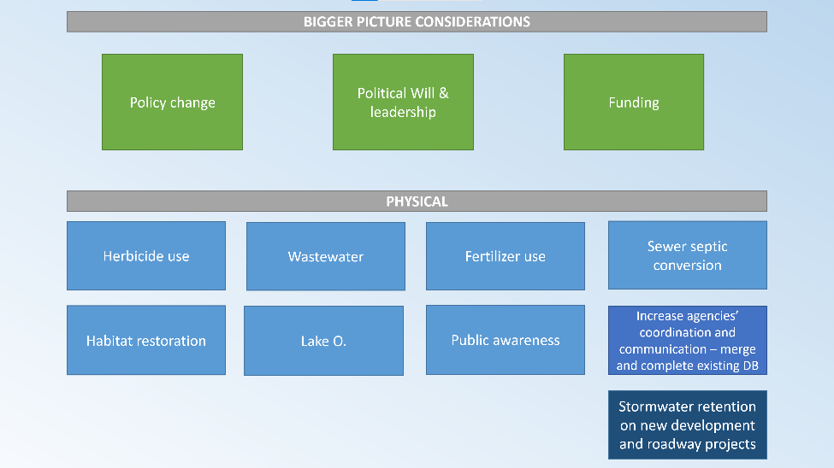

Small Group Activity
Objective: Crete draft Action Recommendations for water quality.
During the last meeting priorities were discussed. Today the focus is on narrowing it down into actionable recommendations. Topics are broken down into three groups and each group has a note taker with a table to fill in.
Discussion:
- I sound like a broken record; we are still missing the piece of who is doing things right now. There might be a program with DEP to remove spraying. There are work plans for five years down the line, and if we had that information, we could identify the gaps.
- Let’s assume that there is nothing done, and we are the committee that says what to do. What we want done.
- If we knew more, we could be more focused
- But we don’t
- But we could have
- DEP: Understand not wanting to spin your wheels and coming up with things that are already happening. We have tried to compile some things that have been presented to the group, but not possible to provide what each municipality in a four-county region is doing. We cannot get this information together. But the potential silver lining is that if the group can come up with things that are already planned or underway, it shows that this group supports those programs or initiatives which gives the municipality or agency that extra oomph to show that it is important to the stakeholders. Maybe help them get funding in the future.
- We are a little group with no power but have the power in being a diverse group, being here a long time and have government people listening to us, so if we can change one thing it’s amazing, and if we can change two, it’s unbelievable.

GROUP | TOPIC | WHAT ACTIONS NEED TO BE TAKEN?  E.g. By fishing stakeholders, gvt, etc. | ARE THERE CRITERIA FOR THIS ACTION?
1 | Septic to Sewer | Prioritizing  - Prioritize close to water systems. Seawalls, canals, river, coastline, etc.  - Lower elevation systems? Those more likely to be flooded with SLR and king tides  Funding  - Government assistance/creative marketing to help with cost. Lottery that maybe city/county could match  - Political pressure on community leaders  - May take federal regulation/force  - Wholesale type buying power to lower price  - Infrastructure bills  Outreach/Education for general public  - Media outlets  - UM?  Areas could lead by example
 | Fertilizer  Herbicides | No fertilizer ever within [distance] of water sources  Prohibit fertilizing during rainy season (like Palm Beach)  Look into difference in types of fertilizer and their effects  More mechanical methods to remove vegetation  Triploid carp for vegetation control
2 | HERBICIDE USE  Challenges  Manual removal is cost prohibitive – including disposal  Herbicide use in lawns  Bill, Gary, and Chuck | - Start by spraying then manage through manual removal  - Education program for homeowners to reduce herbicide use  - New contracts for sprayers – install GPS systems on their guns to track herbicide use – ongoing TAG  - Record what is being sprayed on how many acres – will be tracked and there is an interactive map TAG  - Decrease the amount of herbicide and make sure the use is effective as possible – TAG  - Explore ways to use manual removal debris – expensive, being explored by the TAG  - Support lake management plans  - Increase education on necessity of invasive removal  - No notice that herbicide is banned in the summer at Home Depot  - Encourage living with shoreline grasses (with grasses and habitat for small fishes)  - Create central/uniform message about best practices on herbicide use – Tampa Bay had a good model for fertilizer use in the months of run-off  - Create incentives for native vegetation use to reduce herbicide necessity  - Look at creative financing spread over 10 years for taxes for septic – sewer conversion  Needs to be a goal to decrease their herbicide use by x amt or percent through best practices
 | Wastewater | - DEP was going to be responsible for making sure that municipalities were updating their systems  - Increase fines on municipalities that weren’t updating their systems  - Funds will be provided to update systems  - Updates from DEP on WW and septic  - Recycling wastewater for irrigation or put back into aquifer  - Treated wastewater pumped offshore (?) on the drop, carried up the coast  - Close all of the discharges so no pumping  - Review rules and laws for boats, waste, and pump outs – increase enforcement,  - Establish anchorages with a small fee to provide a boat to pump out vessels  - Filter run-off to collect sediments and trash before it gets into the watershed – i.e. I 95 widening projects  - Could create retention spots to collect the above  - Agricultural industry – encourage the establishment and adherence to best management practices  - Major canals that drain the neighborhood – create some type of filter or wetland on those major canals that go from west to east  Use the updated technology to turn wastewater into potable water on boats
3 | Habitat Restoration | develop living shorelines, seagrass restoration, seagrass mitigation banks  Non-profits/stakeholder groups – partnering with DEP and FWC, raising money and obtaining matching funds through government or private sector, educating people on the benefits of habitat restoration to restoring water quality and how water quality impacts habitats | Any seawall replacement needs to be living shorelines – recommend this to government agencies---add to new sea level laws.  Living shorelines replacing bulkheads---creates habitats  Flood plain predictions – use this data to determine where we use living shorelines
 | Increase agencies’ coordination and communication – central database | Government --  Need to have various agencies talking to each other  Tackle inconsistencies among the agencies  Need to streamline  Mandatory review of policy among agencies so everyone is interpreting it the same way  Compiling all the projects to get them all in once central database  Stakeholders – make these recommendations by continuing to support the recs by speaking with congressional reps. Use the power of our networks to do this. Get the politicians to buy in. | SeaGrant could assist in this central database compilation ----tackle how we can get the groups together to discuss this and get the projects together ---facilitation and coordination through Seagrant ---Seagrant facilitates the development of this database

Discussion
- A good example for sewer septic conversion as the “poster child” could be the Florida Keys
- Yale University, when water rises 6 feet by 2100, Miami Dade County alone would lose $3.7T in infrastructure
- The loss of infrastructure will be trillions of dollars in all southeast Florida. Money makes politicians love.
- One of the issues before then is that as water rises a bit more, septic systems won’t work. So imminent necessary to change to sewer. Septic tanks are already being flooded with king tides.
- People can’t spend thousands of dollars on conversions, but if there is an infrastructure bill going on right now, then we need this to be in there.
- This is an influential group. Politicians need money to get reelected.
- Septic tanks don’t work anymore

Survey

The committee brainstormed what they want to know about their constituency related to water quality?
- Are we putting the names of committee members in the survey? Maybe this attracts responses.
- What is the most important thing to the majority?
- What are the issues? – what are the most important topics OR subcomponents of main topics?
- We want to know how the public prioritizes
- Paul Casanova – radio personality that could help spread the word

Adjourn

Appendix 1

