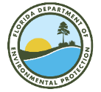

SE Florida Coral Reef Fisheries Stakeholder

Committee - Meeting 7

Virtual meeting via Zoom

6-8 pm, Tuesday August 31st

Summary – August 31st
Overview
On Tuesday, August 31st the first part of two of the seventh Coral Reef Committee meetings was held virtually via Zoom. Project principal investigator Kai Lorenzen and facilitator Joy Hazell attended the meeting.
Thirteen committee members, one member of the public, one Florida Fish and Wildlife Conservation Commission staff, three Florida Department of Environmental Protection employees, and one NOAA contractor also attended the meeting.
The meeting objectives were to:
- Review webinar content
- Develop shared understanding of perceptions of fishing quality in the ECA
- Co-develop survey for constituency
Welcome
The start of the meeting was a quick presentation with an explanation and clarification of the meeting agenda and objectives, reminder of group norms and sunshine law (Slides in Appendix 1.)
Perceptions of the Fishing Quality in the ECA
The committee members were asked to rate the quality of fishing compared to when they started fishing in the ECA. They were asked to provide their answers using a 5-category rating:

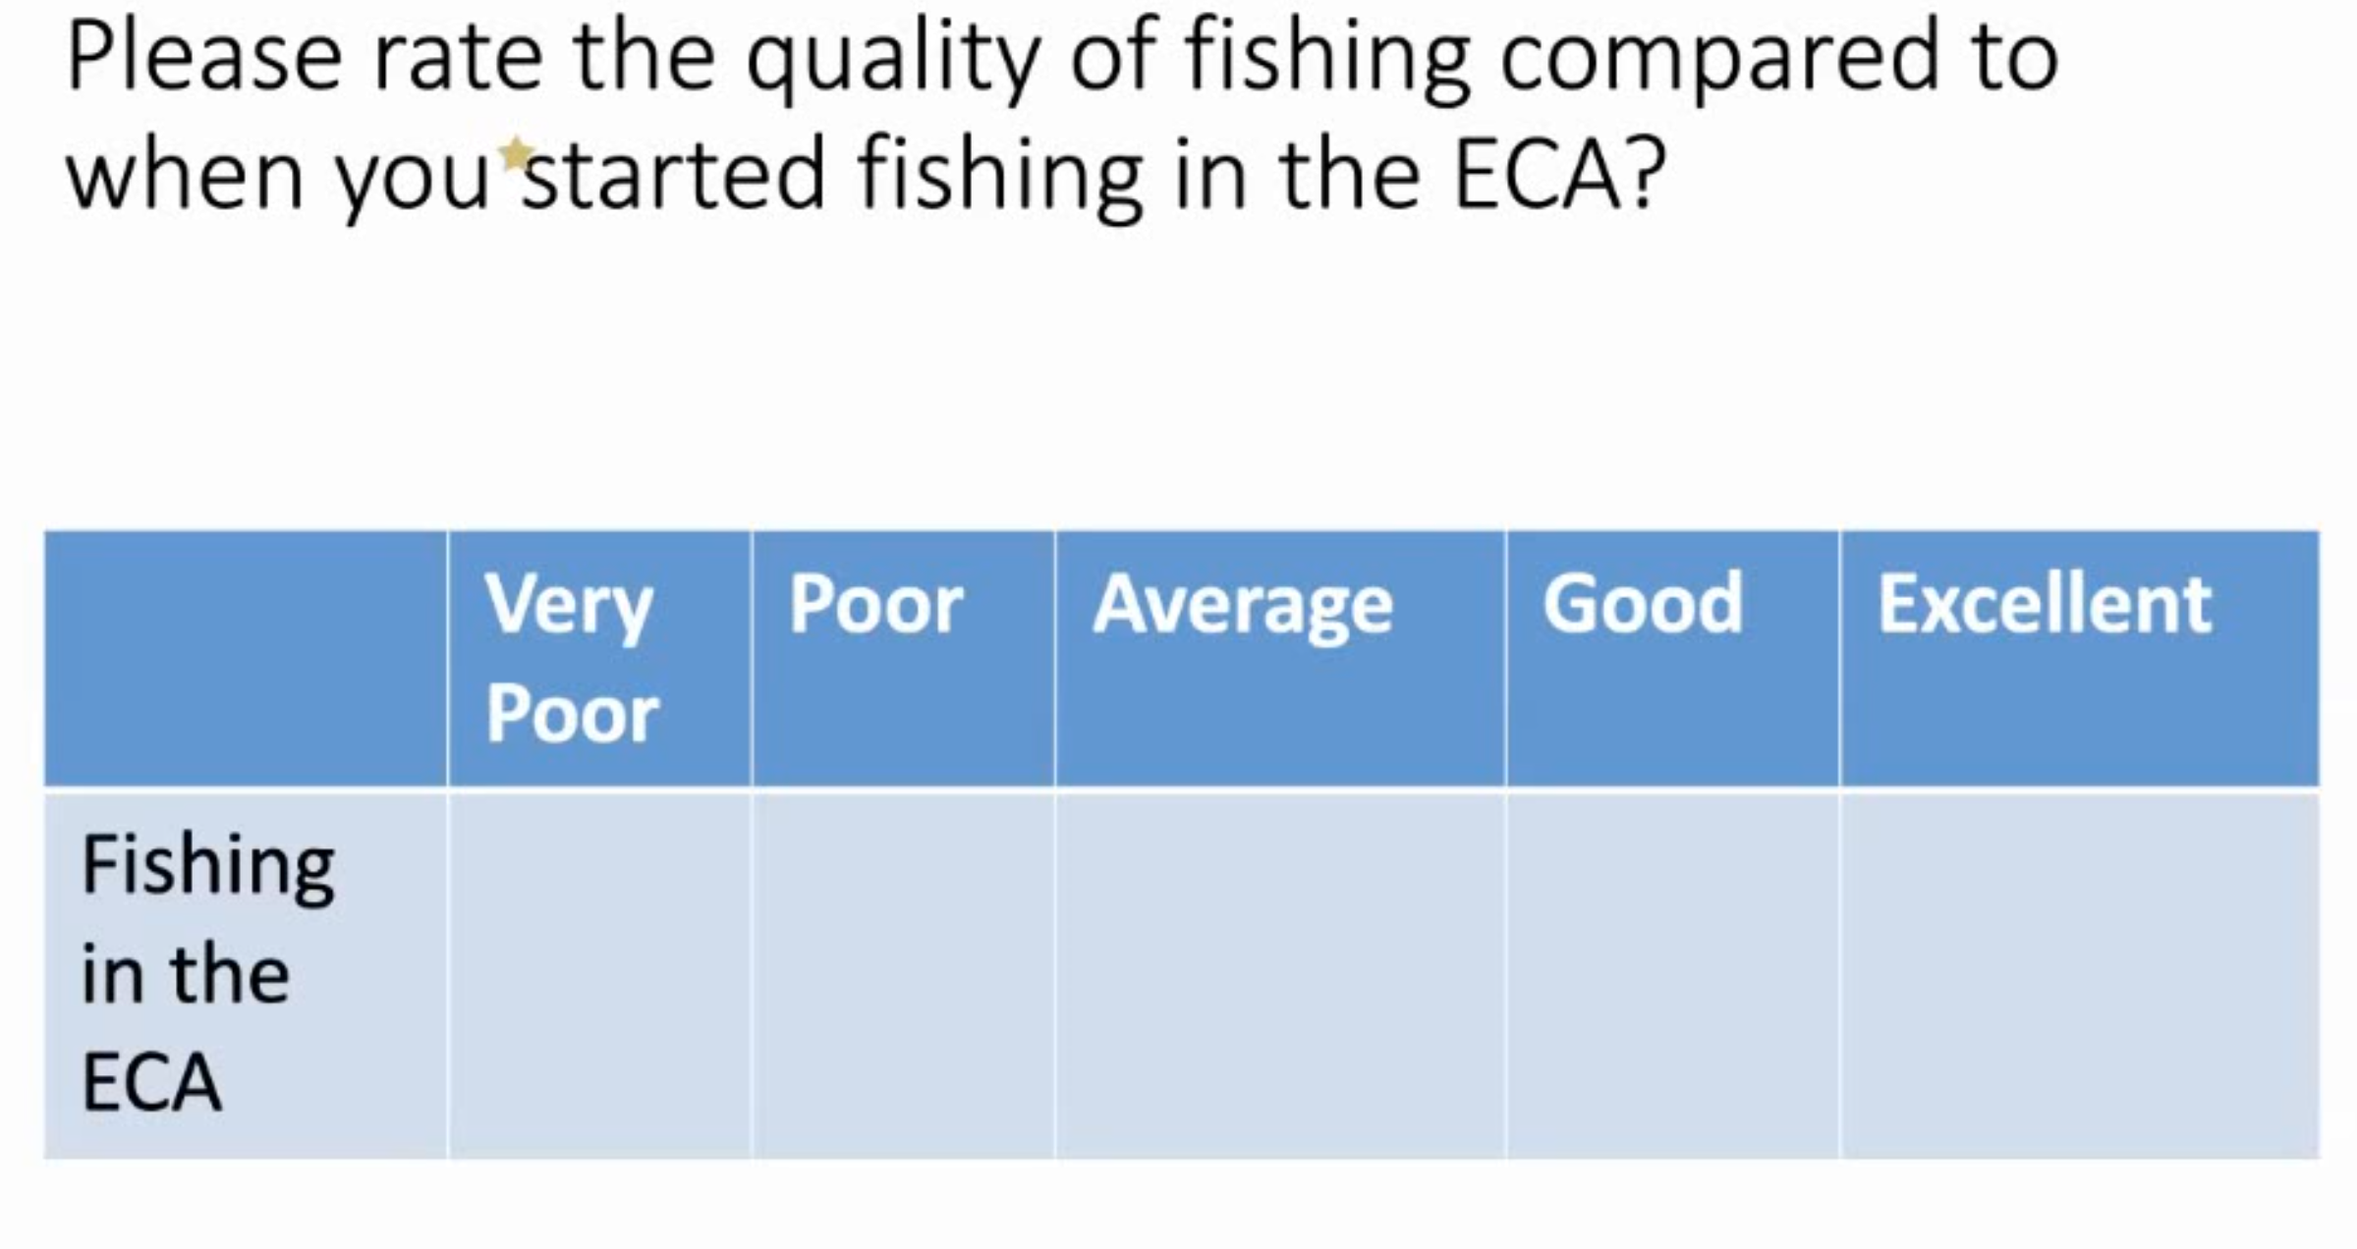
Some committee members viewed the question as “loaded” or oversimplified, and many felt unable to answer this question due to the nuances of the context which were highlighted as follows:
- Fisheries are diverse so different species will give a different quality experience
- Different zones will also vary (e.g. Dry Tortugas vs West Palm beach)
- The time when one started to fish in the ECA will make a difference in perception of fishing quality (10 vs 40 years ago)
- Depends also on the ability of the fisherman
- There are many different angles to answer the question
- Do not set up question as how you “feel” about it. Bring more objective measures
- Depends on what you’re fishing for, when and where.
- It’s different between reef fish and pelagic
- What information are we trying to get? Be specific with the question. E.g. quality fishing for 3 fish species.
- If they have to reach out to community to ask this question, they will need something more specific.
Some committee members did have some views on the fishing quality:
- Today is very poor in Dade County especially in the past ten years because of fishing pressure more than water quality, and marine reserves are part of the solution
- There has been a catastrophic decline in reef fisheries in the last 60 years, which was reiterated by scientists they’ve heard
- Chances of catching a fish have declined – gone from goo to average or poor
- There are fish out there but with reef being gone, there is nowhere for fish to go.

Next, the committee members were asked about the importance of different factors to the quality of bottom reef fishing (water quality, coral disease, fishing pressure, shark depredation, and other).
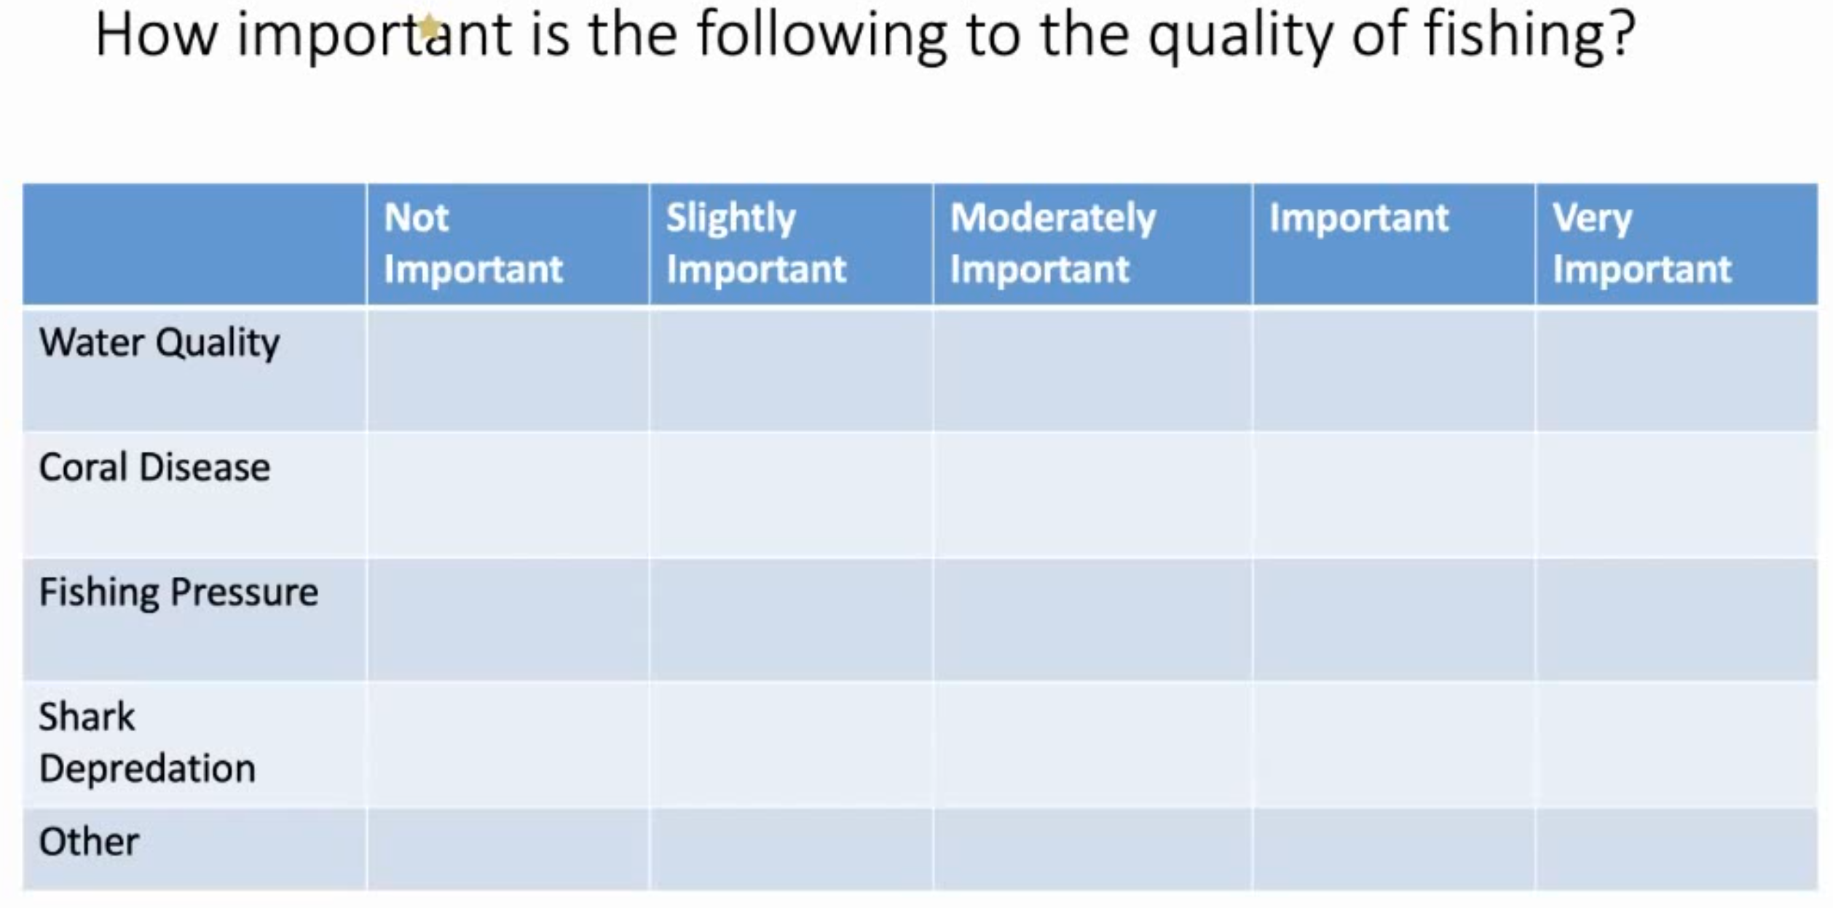

- Water quality is important
- Coral disease is very important since they build the foundation of the reef
- Fishing pressure depends on amount and abundance of fish – since there are bag and size limits it will depend on where you are whether you can keep fish or not
- Shark depredation is problematic
- Fishing pressure is something we could do something about, perhaps also shark depredation with regulations. May be able to do something about water quality but longer time frame, as well as coral disease. So comparing these is difficult because of the different time frames they are bound to.
- Lake Okeechobee needs to be cleaned. If not, there will be a disaster. Phosphorus content went from 40 ppm 20 years ago to 240ppm. This can be a problem beyond fishing, and be a problem for drinking water.
- Fishing pressure we went from hundred thousands to millions of boats so we are not allowing spawners to survive
- One area we can do something about it is fishing pressure, because making changes for water quality is very costly
- Water quality is critically important since it affects all the parts of the ecosystem
- Instead of trying to bring back 2% of dying reef, maybe we could move towards having highly structured concrete artificial reefs for key species
- A lot of pressure on stocks but with tight regulation and tweaking limits could deal with it
- Shark depredation is problematic and causes a nuisance to fishing experience
- Take a hard look to the coral we are growing being impervious to what is happening
- Habitat rebuild is crucial
- Most important issues would be 1- water quality, 2- habitat rebuild, 3- tighter regulations on fishing pressure
- Water quality is the biggest issue
- For coral disease, if researchers cannot figure it out, there is little the committee can do to figure it out
- Could only add more structure for soft corals
- Population growth is bad which puts higher fishing pressure. Only way to tackle this is through FWC who do it well.
- Quality depends on fishery. For example, yellowtail fishery in some regions is better than ever in size and quantity
- Shutting down zones would be highly detrimental because if would increase fishing pressure in other areas.
- Stop divers from feeding sharks – should not feed predatory animals
- Work with the state of Florida and Governor to work on water quality
- Trying to make us make decisions to show fishing is bad for coral reef is bad for what we are doing here
- Anchoring is detrimental to reef
- Putting artificial reefs out there is great. But do it well. Put things out the right way.
- Tackle septic tank issues
- Water quality is job one. There are a lot of things happening: raising Tamiami trail, putting curvature into Kissimmee River, use wells before it gets to Okeechobee, etc. Water Act works towards handling overflow.
- Fisheries pressure – it’s ok if they revise some regulations with growing population
- A lot of work done in invasive aquatic plant management
- Sewer pipes breaking and spills – poor maintenance is an issue for water quality
- Indian River affected by getting sewage into it
- Roundup sprayed in freshwater canals
- Need marine reserves, lower bag limits, more harvest of sandbar and bull sharks and question if marine fisheries are doing a good job at the state level
- Having marine reserve will protect parrotfish and wrasses which keep the reef healthy
- Readdress mutton snapper population. Go back to 16 inches, and drop harvest to 3 fish
- Change regulation to poundage per boat or per person
- Dredging was detrimental to the reef
- Enforcement is difficult
- Let’s get definitions for the types of protected areas we have – catch and release, trawling only, spawning protected areas, target one type of fish, etc.
- Plans for growing artificial reefs in the following years to better tailor recommendations
- It’s illegal to take parrotfish – if they are caught, then there is an enforcement issue, not a fishing pressure one
- Can take parrotfish alive for aquaria but low prevalence of parrotfish harvesting
- People regrowing corals in reef have issues with parrotfish eating it

Small group Activity
In three groups, discuss criteria for more restrictive fisheries regulations to create a set of criteria for fisheries regulation changes.

Group 3 (Marty, George, Patience, Trip)
- Marty – wants MPAs
- Group felt that water quality is the big fight
- Things like inland canals – destroying juvenile habitats from spraying
- Rebuild habitat and nursery areas – developing in spawning depths
- Tighter regulations in recreational angling – close all key bottom species in the key spawn

Group 1 (Patience, Bruce, Art, Capt Dan)
- Bruce said this is supposed to be about reefs. All we have been talking about is fisheries regulations but the reason the group is together because of reefs
- Rebuild reefs –artificial soft corals
- Can’t put an MPA into something that is dead/soft bottom
- Don’t have spawning spots left
- We started talking about reefs and now fishing.
- Talking about water quality is fine because it affects the reef
- This group is about reefs
- Lets look at what we do to enhance fisheries through propagating reefs
- Reefs cant be grown, we have to build them

Group 2 (Butch, Chuck, Harry, Bouncer)
- Talked about poundage and weight for the catch
- Need more law enforcement to protect what we are doing. Otherwise it will be wasted. Pirates will persist
- Examples of closed certain areas for five years then move that close to a different area for another five years – but not everyone likes this idea
- Need more artificial structure
- Members of group decided to agree to disagree about MPAs, that is why they were not discussed, otherwise they would have been talked about in the group during the exercise

Other comments
- We might end up with a lot of material in the near future from condo collapse
- Artificial reef should be in honor of people lost in surfside tragedy
- There were a lot of comments on habitat – inshore nursery and artificial reef habitat, so we can talk about this in part 2 of Committee Meeting #7.

Adjourn

Appendix 1
