Coral ECA Fisheries Stakeholder

Committee - Meeting 13 part 2

Virtual meeting via Zoom

6-8 pm, Tuesday June 16th 2022

Summary – June 16th
Overview
On Tuesday, June 16th the second part of two of the thirteenth Fishery Stakeholder Committee meetings was held virtually via Zoom. Project principal investigator Kai Lorenzen, facilitator Joy Hazell, and cofacilitator Susana Hervas attended the meeting.
Nine committee members, three members of the public, two Florida Fish and Wildlife Conservation Commission staff, and three Florida Department of Environmental Protection employees attended the meeting.
The meeting objectives were to:
- Finalize fisheries draft recommendations

Welcome
The start of the meeting was a quick presentation with an explanation and clarification of the meeting agenda and objectives, reminder of group norms and sunshine law (Slides in Appendix A). Jeff Renchen was also introduced as a member of FWC.

Tuesday Recap
Recommendations were tweaked by the group to read as:
- Research - find out what reef species are aggregating where on the reef so they can be protected if appropriate.
- Create areas to protect spawning aggregations based on spawning season and location. Identify areas and species to be protected based on stock assessments and best available science. Only restrict recreational and commercial activities and delineate no take zones if species being protected are reef fish. Otherwise sail pelagic fishing should be allowed.
There had been concern with results varying with respondents’ years of experience fishing in Florida. Preliminary results showed that grouping responses into years of experience did not change the response patterns.

Discussion:
- Recommendations on spawning aggregations will go through a legislative process. Working with law enforcement and other groups to get feedback. So first we need feedback from everybody here.
- Some people mentioned slippery slopes on Tuesday, thinking it could bring a blanket closure. So, recommendation on spawning aggregations was clearer and more delineated to address this.
- There is a process with a lot of public input on these areas because there might be issues we might not be aware of. People able to speak in commission sometimes will go through various iterations depending on the input they hear. It is a good and fair process. Highly vetted process.
- Separating by recreational anglers and charter captains has made a difference in other surveys. Not years of experience fishing. The sector made a difference.

Group Activity
The group discussed in a large group the four final draft recommendations.

Spatial Management
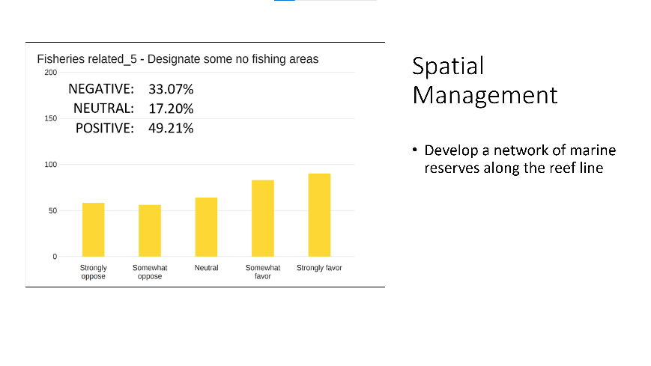
- Understand need for spatial management to a certain extent. I would strongly object to the name of marine reserves. Call it what it is. No anchor zone. Establish it as such. If it is a spawning aggregation, protected area, call it that. The biggest push back you will get is from the name. That is your biggest impediment. Because a lot of people understands spawning aggregation areas, anchor protected areas, catch and release areas. Term reserve is a big negative in their eyes. When you look at this one. It says designate no fishing areas.
- Have not seen nor heard the managing entity for fisheries within state waters saying that we need to have this. Haven’t heard it for any particular species. Haven’t heard anyone saying in a stock assessment that we need to close areas to protect fish. To me spatial management is a tool and can be used effectively in certain areas, and it has been relatively effective in the Tortugas because it’s large and far away from populations. I think that when people hear, we want to close areas to fishing to protect fish – it’s a great idea! But then you put pressures on the areas next door. Because people will continue to go fishing. It is the last tool in the toolbox. Used after bag limits and other types of regulations.
- This is the no fishing areas as marine reserves. I am on board with what Gary said. Spatial management if there are areas where we don’t allow anchoring. About no fishing zones, there are better ways to control that. Like regulations for spawning aggregates. At least one month, for sure, during key spawns like they do with groupers. Or catch and release but have a no take. They are in the most vulnerable months. With sharper management. Or certain zones that could damage reefs with anchoring, I could see that.
- Monthly, two months or three months of closures area really tough especially for the charter business. When grouper opens there is a wild rush to go out there and catch grouper. We need to figure out scientifically where these fish go. Must be able to designate areas like we did with Dry Rocks.
- FL Keys have marine reserves. Some in Dade County. Most of them are 10-50 feet of water. You are not supposed to go in there, fish or anchor. They busted 50 people lately in these reserves. Because people go in, fish and anchor. In the chart it says don’t go in, don’t fish, don’t dive. So, there is another issue with special management when you designate full periods. Its enforcement, which is an issue. I don’t want to close seasons too much. Just find out where they are and close those areas. Get more scientific or people won’t buy into it.
- There is a law of no anchoring in Florida. Applies to all of the reefs.
- This idea is part of the reason why we are all together right now.
- Went to Europe to see marine protected areas. Marty Arostegui, Gil Moratori and I have gone through south Florida talking to people. Marty and I are very in favor of marine reserves. There is as an example, like in the northern keys, one of our members was told to take kid trawling for groupers. Not knowing what buoys were, when he went by the buoys, they caught groupers. Even years ago, there were a lack of groupers outside the protected areas which indicates the success that you can have with the protected areas. Allowing grouper to grow bigger and schools of yellowtail to be thicker.
- Very in favor of marine reserves
- Denying its effectiveness is a problem. We believe designating a few miles square cannot be a negative factor in the overall picture.
- Spawning seasons, close them for grouper, find the areas that are productive. Close areas for the time of the spawning. I don’t think you need to close areas where you can’t go in. There is going to be too many.
- Over 50 boats, will still go in there and do whatever they do if there is not enough enforcement anyways.
- Closing in spawning seasons is your number one deal. And water quality. I don’t think marine protected areas fixes the problem.
- There is a lot to unpack with this particular issue. It is very contentious. In the description: “Develop a network along the reef line” is so vague and an over-reach. Because to develop a marine reserve you have to draw lines on a map. On a chart. And part of the reason that the Tortugas Ecological Reserve was so successful is that they got everyone down at the table. And they drew lines on a chart. And until you do that, you can say this benign phrase here, but you have to reach out to the local community and draw lines on a chart and make your case as to why the area within those lines within that area is so unique and important that needs this level of protection.
- We supported concept in the Tortugas and were vilified. But it is proven to be highly successful and did not put anyone out of business. There are other areas they go to and fish. But we did protect spawning aggregations there. The wording of the description is way too basic. The recommendation should be If all other tools available, that Gary has talked about, bag limits and closed seasons, and all those things, If those tools don’t address or aren’t effective at the goal of setting aside whatever areas within those lines in the chart, then a no fishing zone is worthy of consideration. But need to make the case of why it is and why other tools aren’t effective at it.
- Maybe playing both sides of the fence. I don’t have a problem with marine reserves. But do we need a network of 20%? No, I don’t think so. But if they are really special places out there so worthy of protecting, we should prohibit fishing, we should protect it. But have to draw lines on a chart and have everyone at the table who would be affected by it.
- You will turn so many people off with that recommendation. Must be more descriptive.
- Sat in South Atlantic Council snapper grouper for years. We looked at no fishing zones from NC to FL. Picked 8 or 9 of it. After all these meetings - actually drew lines - some ledges, specific wrecks, were made off limits. We all did it together, charter, commercial scientists – these guys gave input of where they were spawning.
- Look at California and how it disrupted the whole recreational and charter fishery with the preserves that they put there. It’s a mess. And I don’t think any more fish came back.
- That was one of our biggest arguments with what OFR were trying to do. Some people were from California. If my memory serves me, they were supposed to review those areas after 5 years. And they never did it. Didn’t have the money, and they just kept it closed. That is why shimanno left California. That is why I have a job. They didn’t want to see that happen in Florida.
- OFR language said something to the effect that MPAs were a tool in the toolbox. And I don’t think anyone here would disagree that it is a tool in the toolbox or that if there is a very special place that needs to be protected, I don’t think anyone here would argue against that – talking about spawning aggregates. Signed letter to Dry Rocks and to protect Tortugas. If there is science to back it up and needs to be protected, that is ok to say. But to close 20% of the reef line that will start a war. That will get bloody. If a very specific place needs to be closed, then close it during spawning season and show the science. But I haven’t seen the science or stock assessment saying that there is an area like that. Not saying there isn’t one. Have to talk to FWC and see what they say. But they are a tool in toolbox and not what we need to jump into.
- Agree with it. If ever make a complete closed area, reserve. Need to make it across the board. Nobody allowed in there. So, everyone has the same experience.
- I agree that if there is a special area that needs to be closed, but to follow the California example, maybe there should be a mandatory review in 5 years. And if the review is not done, then it opens again. To encourage the review. I don’t like closing something forever and not finding an alternative.
- Follow up what she said. A sunset provision, unless it’s renewed.
- Tuesday’s meeting, I brought up a specific site south of government cut, 35 feet of water where the mangroves spawn every June July. And the boats pile up there, and it would be a great place we could really increase a lot of mangroves for the rest of the year, if that was a closed spot. Probably in Miami-Dade County there’s another one off the Cape. That's what I brought up as known spawning areas where we know that we could close that site, specifically at night, and not a lot of people go in there.
- Most important spawning aggregation to close is a wreck called the screamer off Ocean Reef.
- I have watched over the years that become a very prolific cubera snapper destination in the summer months. Then decimated by sharks and boat traffic. Then everyone forgets about it, sharks leave. Population increases, and boats and sharks return. This would be a good site to protect with 5-year program. Could be good for the protection of the cubera snapper.
- With today’s predation of sharks, catch and release can’t work during spawning aggregation
- About California marine reserves, California closed all bottom fishing. no deeper than 100 feet. For numerous years. And after that it was so successful that it now opened to 200 feet. And monitoring all this stuff. Next step might be that they will be closing one depth and opening deeper water. We might be missing the boat on everything if we don’t get on a program to encourage NOAA to start controlling the population of sandbar and bull sharks because they are completely out of control.
- There is a perfect example about that screamer wreck. That local knowledge, drawing lines on a chart. You could make a strong case to the community that fishes down there and could get buy in if you explained why it needs protection. But can’t get there before you sit people down and draw lines on the chart.
- May be an opportunity here. Strong support for artificial reefs, and a lot of negativity around taking peoples fishing spots away from them. The two could be combined. You can take an area where nobody fishes and there are no existing resources. We are doing this in Palm Beach County with artificial reefs. Area with no resources and no fish. And it is almost like a de facto marine reserve because of depth and current. People do fish but there are natural protections. If want to develop network of reserves, draw a chart where there are no resources. There are plenty of those. Pick spots that you want to create no fishing areas. People are not fishing there now anyways. So, you can create new habitat to repopulate the reef. Lot of support for artificial reefs and negativity about taking fishing spots from people. So those can be combined in a very successful way
- Catch and release – most people know it’s closed season. Not many people will use time to catch and release since they can’t keep them. But give the opportunity to fish, don’t have it closed to fishing. Have no take for spawning aggregations, where you could leave catch and release.
- Remind group that the point of all these recommendations, is to protect the coral reef. Unfortunately, placing them in a location without resources does not achieve that main goal. And we still are delineated to 3 miles offshore. Appreciate trying to find balance with improving fishery and reduce impact on fishing. But wanted to remind that we want to protect the reef including the fish.
- I am hearing not a lot of consensus here. Some people for it, concerned for it. There is a level of consensus around this needs to be a more in-depth process. Have people come together and draw lines on a map. And then make decisions.
- Let’s look at our options – rewrite this, explore potential for marine reserves and protect appropriate science and stakeholder engagement process.
- It was an interesting discussion, and a lot of good points are brought up that give us ideas and criteria about sunsetting for evaluation. Good to summarize those to not lose them. Even if the committee does not feel like making a recommendation about it. But also, maybe a recommendation could be formulated that sets out criteria rather than a recommendation for or against. I would hate to lose this. And honestly, we don’t often get forums where there is good discussion about these issues. And I think we have come with this committee to a place where we can have those discussions. So, we could keep this and turn it into something that can be used in the future.
- Have a set of criteria about spatial management and marine reserves. This is where the group is – but not necessarily make one recommendation.
- State is not against marine reserves. State will close areas when appropriate. we evaluate if there is an area. We evaluate at the stock level. When we close areas, we look where distribution will go, and we go through a process to make sure that we make effective closures. So that's why we go through this process that we do for making sure that we're not just closing areas for sake of closing it. We really make sure that these areas are effective and that'll be more effective to close an area, than it would be to change a bag limit or change the size limit. So I feel like that's the process we use and what most people like. And I agree with Tom’s points, as well as that it's better to look at these areas of just case by case basis, instead of just saying let's close off of a network. What does the network look like is the ultimate question.

Bag Limits
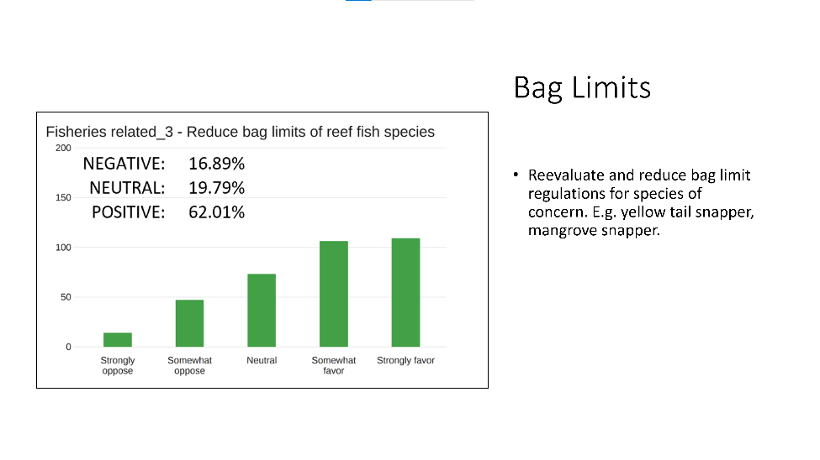

Discussion:
- I don’t think we are the people to be saying that we need to change bag limits. That is the purview of the controlling agency, which is FWC. And if we feel like there is a problem then we need to bring this to the attention of FWC and let them study it. Not for group of people to say we need to change bag limit. Because we are not qualified to do that. We pay people to do that.
- Depends on the areas you are talking about. Coral ECA, there are local areas that are depleted, but we look at area as a stock level and rely on fisheries independent data. Also on stakeholder feedback. Recommendation should be about concern about a species more than the bag limits.
- Maybe we have a lot more people fishing so maybe we should reduce what they can take. I don't understand how we can have five mutton bag limit per person.
- We could arbitrarily say because we now have four times more average that we had 10 years ago and we have 40 times more hours than we had 20 years ago and we all have GPS and go fast boats get anywhere and great tackle and braided line. Maybe we have a lot more people fishing that we use to catching fish and we maybe should reduce what they can take.
- One example, if it was one mutton snapper a day in Miami-Dade County you have 6000 boats offshore and each boat caught a mutton snapper and they averaged five pounds a piece but he got a lot of mutton snappers dead. We should be looking at it that way, that should be one way that the state's looking at it, it should be doing that.
- And I did some research. In northern California, where they shut down the rock fishery, those fish live up to 200 years is 70 species of them. They've come back really good they can fish out the 360 feet of water now, you cannot drag cannot long line, you can only to hook in line. So, they got rid of that nobody fish for almost 20 years, and now you can only hook and line and they did come back alright so there's an update on what you were bringing up.
- Mutton – we have a disaster with increased fork length of mutton snapper. From 15 to 16 inches or 16 to 18. Smallest mutton stayed in shallower waters.
- Out of 40 throwbacks, with sharks, maybe 2 or 3 make it down. And mutton biomass, a lot is right under the size limit.
- So many fish if not handled right and not sent back down right won’t make it. And in Palm Beach it is going to get eaten right off the line.
- Reevaluate and assess is the wording. A recommendation to the FWC but could take off the examples from the recommendation.
- Could change bag limits. Can’t blame snappers for fishing them. It is the sharks that are not letting them go back down. That’s the way to look at it.
- The cormorant bird, they also catch the trout when you release it. Catch what is causing the problem. All you do is feed the sharks.
- Need bag limits. It helps. People are getting smarter because we have bag limits, and we need to train people doing this.
- Hog snapper divers are excited. They bring back really nice hogs. I wanted to call FWC because they brought back small hogs. We need to train these people. Still will have those guys that whack everything.
- Maybe instead of dialing it down and saying bag limits, why don’t we say reevaluate bag limits for fisheries of concern.
- FWC can do this
- Reevaluate bag limit regulation for reef species of concern.
- Some species are getting more hard hit within the ECA.
- Redfish went from three areas of the state to nine. So they could have better control over different aspects.
- That was seatrout many years ago.
- Haven’t looked at data for coral ECA specifically. Don’t know if it is.
- In Biscayne we have increased by 20% and we keep monitoring. It can be done. We did a lot of research and baseline sampling to see if regulations are being effective or not.

Shark Depredation
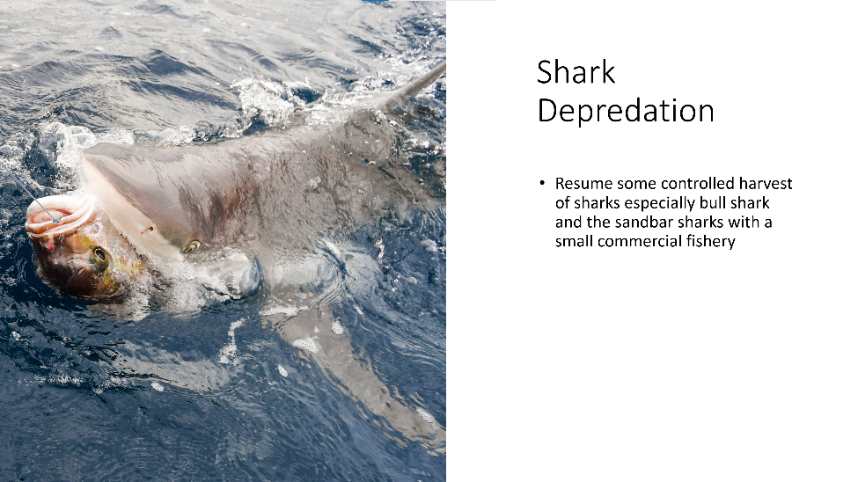
Discussion:
- Everybody here knows there is a shark problem. The challenge is that shark management is super complex. Largely managed by the Feds. Not the state. Just some. Mostly a longline fishery. No longlines allowed in state waters to my knowledge. There was a panel that met last May 2021 at FWC in Miami where they discussed this – Guy Harvey and a bunch other people were there. Everyone acknowledged that there is a lot of shark predation but it is outside of our wheel house.
- I think we have an obligation to complain to our state and they can complain to the Federal Government. So that those that do manage shark populations can be aware of what a huge problem it is. Longline shark fishing in federal waters and not allowed in state waters but plenty of longline commercial fishermen that could work in that market. Impossible to sell sharks now, so commercials are not that interested.
- I hear exactly what he is saying. I'm thinking, maybe something more general about looking at shark depredation and developing a strategy to address it, which could include regulatory changes.
- FWC and NOAA are talking about this right now
- Nobody in this committee is in a position to recommend how to go about and do this, but we have a concern about it and want feds to look at it. We can’t do more. Perception of us killing sharks, and shark fin soup doesn’t fly well in the US but we need to make ourselves heard. Shouldn’t make any recommendations for regulations. Not in the position to do it.
- Explore shark depredation and develop strategies to address it.
- Consolidation is good. There is not much we can do about it.
- About two weeks ago I participated in the highly migratory species advisory panel workshop and they addressed this issue. It’s a horrible problem. Many people call it a success. Many people call this a conservation success story.
- Roadblocks to solving the problem are complicated and interesting, for example, we had an explosion of interactive shark feeding dive trips. Jupiter does this and lots of boat do it. Take people out, throw them in water and dive with sharks. Really cool to do. But they are changing the behavior of those animals. Sharks don’t want to leave because they will get fed when boats come. I asked why is it legal in federal waters and state made it illegal, rightly so. I learnt, it is considered a non-harvest activity, so NMFS, NOAA and highly mig. Species have no control over it because they are not harvesting shark, just interacting. This activity is prohibited in the Pacific and all the Pacific Islands, and specifically written in Magnuson-Stevens Act but that same clause language doesn't exist for the Atlantic in the Gulf of Mexico. I think that's one area that needs to be addressed when Magnuson-Stevens and comes back up for reauthorization, we need to get that language in there, unless you think altering the behavior of sharks by feeding them and putting people in the water is a good idea. I think that's something that needs to be addressed down the line. The highly migratory species folks have their hands tied on that particular activity. The other roadblock to helping solve this problem is this stigma around sharks. The commercial folks that were on this workshop panel all said that if we could, if we had help developing redeveloping a shark market, you know it would be worthwhile going out there shark fishing but sharks aren't considered as such. There's some blue label like this sustainable fish label, and so you can buy it at costco or target or walmart and it has that seal of acceptance. Sharks don't have that and that's something that's designated by - I don't know if it's the Food and Drug Administration, or some government entity, and until sharks get that designation it's going to be really hard to develop a commercial fishery for it.
- To Gary's point in the chat, this problem is widespread throughout the Gulf of Mexico and up and down the eastern seaboard and there's a lot of reasons why this is probably happening it's just not one thing I mean, but the elimination of the commercial fishery certainly, has had a huge role in this and then this whole shark feeding activity is just mind blowing to me.
- I feed fish in my lake. I walk out, I tried to test a line and they all came to be fed. Behaviors can be changed. Sharks learn and know that boats feed them.
- Every dock has a fillet station. Marinas have it. The second the water goes off mangrove snapper tarpon, all species go in there. You’re not supposed to throw carcasses in the water – because it pollutes the water, although it all gets eaten. Snapper and tarpon are there. Now also sharks and bull sharks are there. It’s a feeding habit. There are more of those than ever, in 63 years. Never in my life have I seen these many bull sharks. Guys won’t go in the water to clean the boats because there are so many sharks. I don’t want to say not throw the fish, because that causes more plastic pollution, but sharks are a problem.

Pole and Troll Areas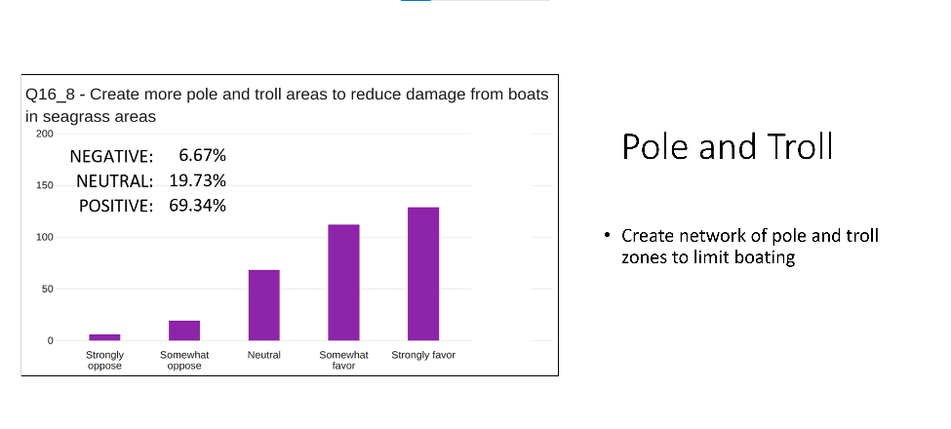

Discussion:
- How this recommendation impacts the Coral ECA: Technically, within the entire ECA there is seagrass offshore. There is actually quite a lot. Different fish species use other habitats in particular in their younger life stages and so, there’s a number of seagrasses different species and different entities within the intracoastal waterway. We try to limit them to the box of the ECA. If you do have suggestions or you know wording that kind of incorporates or allows us to partner with the agencies that manage the intracoastal waterway and the inlet we can certainly do that going forward.
- That is a huge amount of seagrass in key Biscayne. Has a lot of loss of seagrass happened off Key Biscayne?
- There are a number of beach renourishment projects
- It has to do a lot more with mitigation and monitoring and even planning features and programs differently so that the sand that they place there sort of stays in place as opposed to eventually equalizing out over time on, which is what it normally does so.
- To my knowledge and through the data that they collect for those projects there hasn't been a decrease in the seagrass offshore,
- If we have lost seagrass in most of Biscayne bay – middle bay and up – and st lucie has the issues we all know. And lake worth we all know the issues there. Only some seagrass there. What does this actually do? This is not the Keys. In Isla Morada there is pole and troll all over the place. But in our jurisdiction, what would this do? Or should we be talking about the Keys? They have them there. What does this do?
- I think the intent was not to limit boating, as to protect seagrass. Recommendation sounds negative. I would change to – protect seagrass resources. There are not many places where this would come into play in the ECA if we talk about from the beach out to the reef edge.
- To protect seagrass resources. Not to limit boating.
- Some areas are too deep.
- Limiting boating is not going to get anyone to buy into that statement. And agree to be able to protect resources, but not sure how you are going to pole and troll offshore.
- ILook at title inside the slide. Look at statement in the graph, but nobody would agree to the statement about limit boating.
- That might have been because of earlier anchoring on sandbars. Maybe that is why we came up with this. Why would we have a pole and troll zone to eliminate having these guys.
- Create pole and troll areas to reduce damange from boats in sensitive seagrass areas. ** Exlplore creation of pole and troll areas to reduce damage from boats in sensitive seagrass areas
- It is a noble cause, and in our situation, area specific, we have to consider spraying and what is dumped into the water canals.
- Must look at discharges from Loxahatchee which are damaging the seagrass.

Public Comment
No comments

For the good of the group
Jamie Monty shared her farewell as she transitions from FDEP to NMFS NOAA to her new position. Although she will remain a collaborator in the project.
The next public meeting will be held August 23rd and will be online.

Appendix A

