Coral ECA Fisheries Stakeholder

Committee - Meeting 13 part 1

Virtual meeting via Zoom

6-8 pm, Tuesday June 14th 2022

Summary – June 14th
Overview
On Tuesday, June 14th the first part of two of the thirteenth Fishery Stakeholder Committee meetings was held virtually via Zoom. Project principal investigator Kai Lorenzen, facilitator Joy Hazell, and cofacilitator Susana Hervas attended the meeting.
Six committee members, three members of the public, two Florida Fish and Wildlife Conservation Commission staff, and three Florida Department of Environmental Protection employees attended the meeting.
The meeting objectives were to:
- Overview summary results
- Finalize fisheries draft recommendations

Welcome
The start of the meeting was a quick presentation with an explanation and clarification of the meeting agenda and objectives, reminder of group norms and sunshine law (Slides in Appendix A).

Survey Discussion
There was a presentation with a summary of survey preliminary results so that the committee members could understand the perspectives of their constituency and use the information as a reference when discussing the remaining recommendations.
The summary included the responses from a random sample of recreational reef fish permit holders from four counties. Response rate had been 1.8%. The results did not include commercial or charter yet or responses from the committee member networks.
The summary for each question was described and the committee was probed to discuss: Are there any questions about the slides? Does anyone have key takeaways from the slide?
Below are the discussion points that occurred for each section.

Q8 - In your opinion, how would you rate the current condition of each of the following marine resources

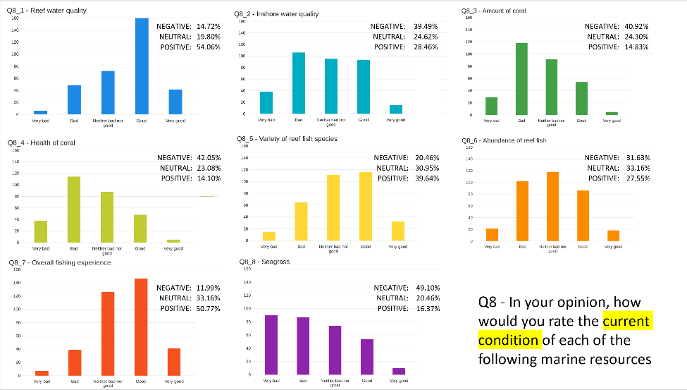

Discussion:
- Studies from colleagues at UF looked at where anglers were coming from – to know where people come from who are engaged in marine recreational fishing in every county in Florida. Miami-Dade, Broward, Palm Beach and Martin account for 90% of effort in that region. A lot fish in county of residence, and most come from the same place. That is why we sent survey to those counties.
- 1.8% response rate from the sample. Not sent to every reef fish holder.
- Sent it to 30k, not everyone. Response rate is not very high. We used to get higher response rates. Maybe tells a bit of survey fatigue. They have filled in many and now they are less inclined to do so.
- Random sample is the most representative of surveys that we will get. We have surveys to send to your networks which are more self-selecting. This is the most representative sample we can get.
- Since 20% of fishermen catch 80% of the fish, those numbers are really good. Cause many people go out there and don’t know how to fish.
- Lot of people taking the survey don’t know the intricacies or depth of what we have been talking about. They look at the surface.
- I went on fishing trip, filled both boxes. If that was your trip, you would say it is really good. But I fished 20 times and didn’t get any because they are either not big enough or sharks eat them.
- Water quality, we know how that looks.
- Is there any mechanism that we take into consideration based on the survey respondents’ years of experience with the resource? Because there is a shifting baseline syndrome. How people look at resource when they have started fishing is different than those who have fished for a longer time period.
- We can look at avidity, location, and period of time fishing.
- How long they have been utilizing will make a difference on how they see the status.
- There is good information in here. But want to make sure we have all the information we need.
- Missed critical expertise that we should at least filter into this information.
- Very disappointed to not see commercial and charter information in there.
- We will add that. Commercial and charter are planned to be surveyed.
- We discussed with FWC when we were putting it together, and they suggested to use reef permit holders.

Q9 - Based on your knowledge, please rate how important you think each one of the following factors is in impacting the coral reef ecosystem in the Coral ECA.
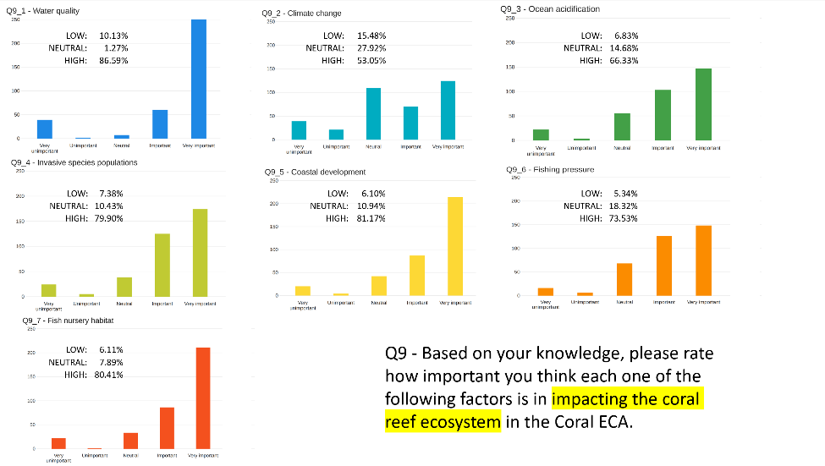

Discussion:
- All high importance – look different to the previous slide.
- On water quality it is very important. And then they say water quality is very good in the past slide.
- People may not have the kind of information that we have having spoken for the last two years.
- Fishing pressure turns up as fairly important here even though people were fairly happy with the fishing.
- Not all these relate very directly because we ask different questions about status and impacting factors. It may show some disconnect.
- People seem to understand that we need more nursery habitat.

Q10 - Based on your knowledge, please rate how important you think the following broad measures are to improve conservation of the coral reef ecosystem in the Coral ECA.
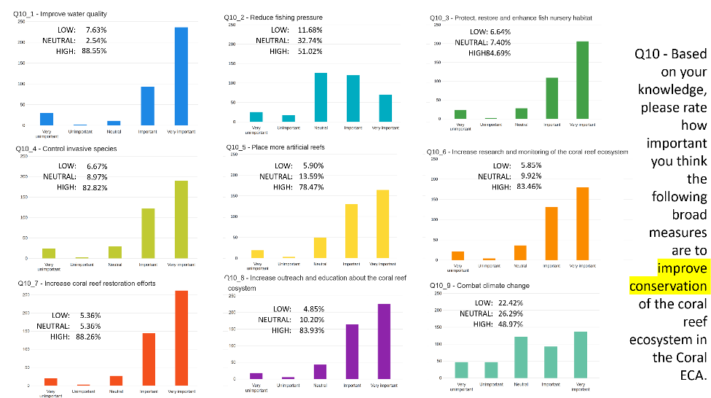

Discussion:
No questions

Q11 - Based on your knowledge, please rate how important you think the following broad measures are to improve fishing quality in the Coral ECA.
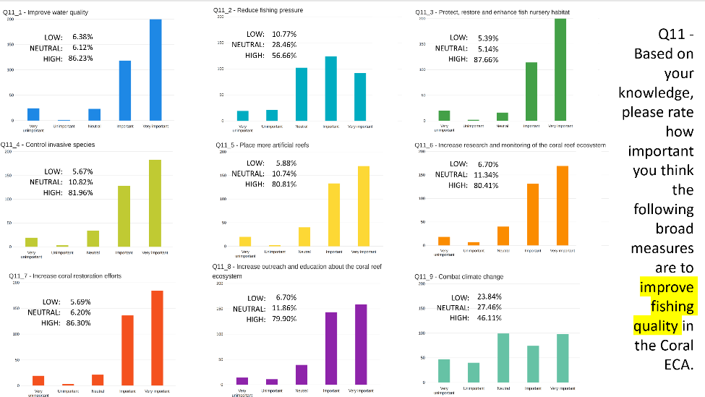

Discussion:
- Interesting how unimportant people feel climate change is impacting reef and fishing when it is a big part of the issue.

Level of support for management ideas – Water quality
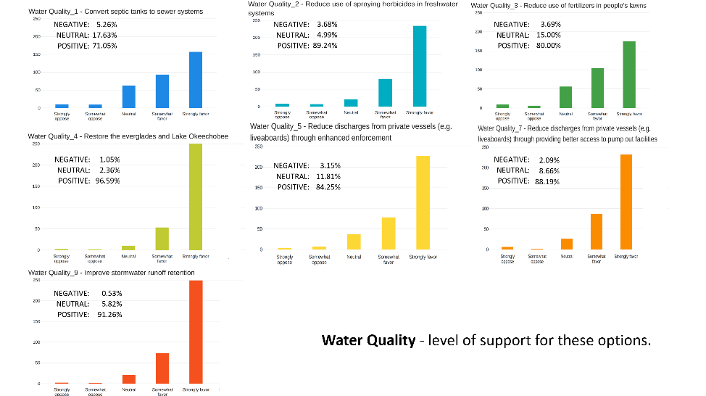
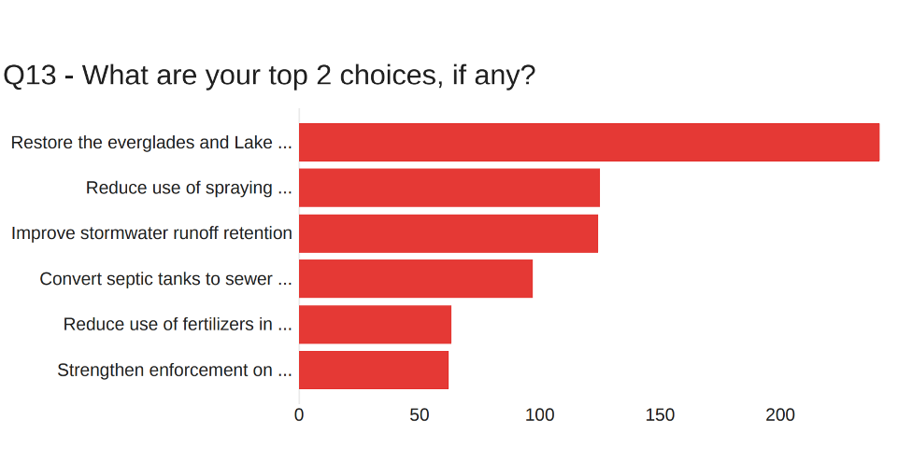
Discussion:
- It was mentioned in the last meeting that people were not receptive to the cost of changing their septic tanks out and this kind of shows it.
- The last slide shows preference actions. The overall when ranked one by one. But still 71% favor septic to sewer conversion.
- Looks like everyone agreed with the comments that we put up. It’s clear. What we consider to be important. Everyone else agrees with that.

Level of support for management ideas – Fisheries related
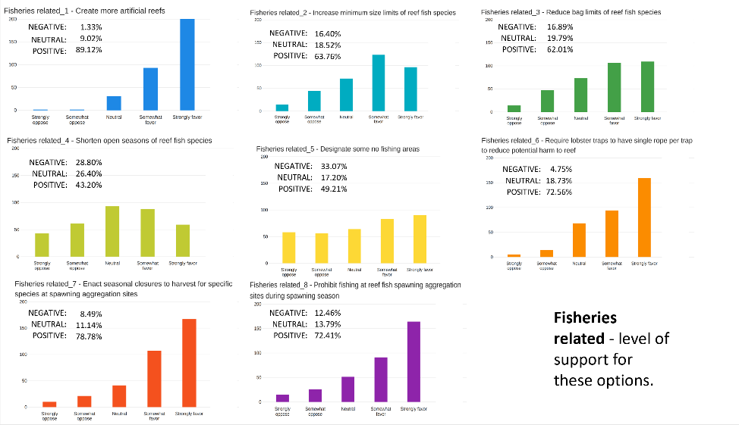
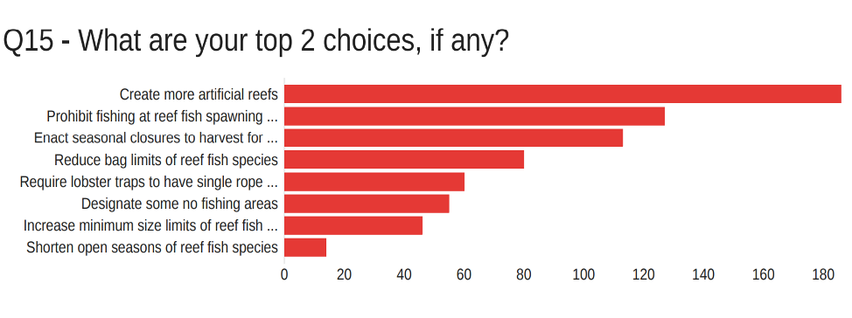
Discussion:
No comments

Level of support for management ideas – habitat related
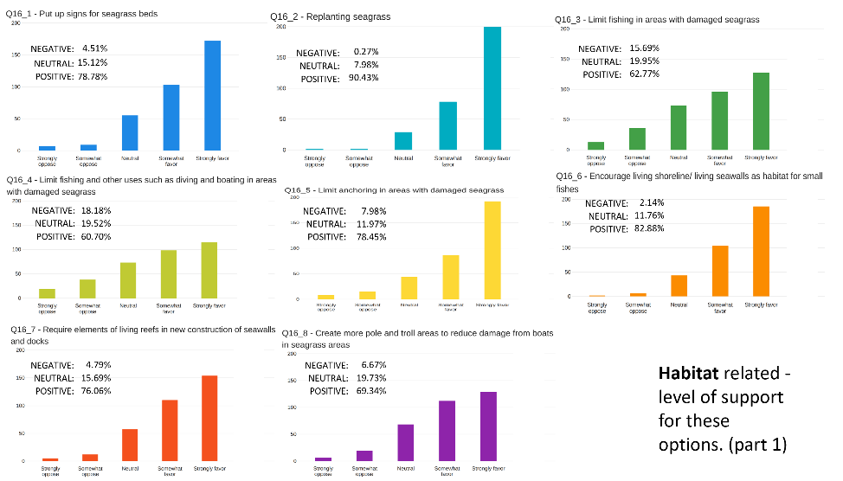
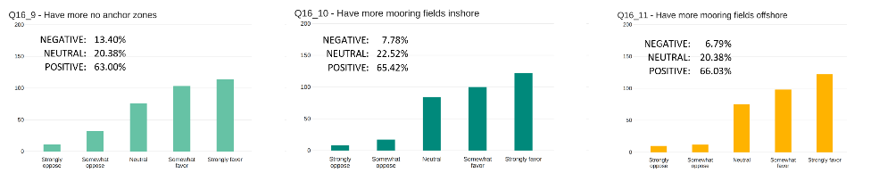
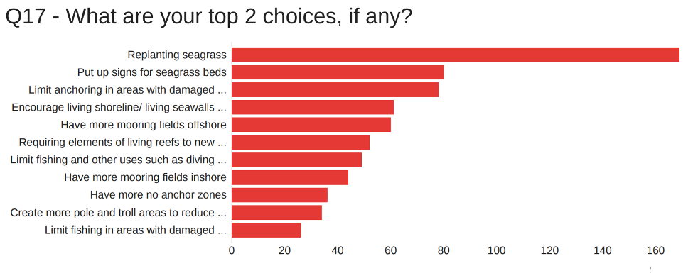

- Notice how small the negatives are for these ones? Most skewed to the upside.
- I think everybody's done a really good job at what we mean putting everything together seems like we were all there.
- Point out that we have buoys safety concern for more signs. Would like to find a way to mitigate that. No problem mitigating it. My concern is more safety hazards with having visible signs.
- An observation, people were supportive or neutral about just about every measure that was on the table. But clearly people are more negative about measures that impinge on their own activities. It was interesting looking at the fishing measures. Short seasons are least popular. Even more so than no fishing areas. And artificial reefs are the most liked.
- Others that are interesting, that involve a higher degree of resource protection and are popular, like spawning aggregations. Coming back to looking at the septic to sewer, I guess one of the reasons for that, it is less popular than restoring the everglades, is that it will cost the individual, versus paying for restoration.
- Some really good measures here in all categories that enjoy a good level of support. And matched with a lot of the things the committee has discussed.

Group Activity
The objective of the group activity was to finalize two draft recommendations on spawning aggregations:
- Research - find out what species are aggregating where on the reef so they can be protected
- Create areas to protect spawning aggregations based on spawning season. Only restrict recreational activities and delineate no take zones if species being protected are reef fish. Otherwise sail fishing should be allowed

Discussion:
We need to see if the fish that are aggregating need additional assistance or not. I would hate to make a blanket statement that any fish that is spawning needs the closure. So, fish that are being overfished or experience overfishing. But not sure how to word that.
Down that line, think about this. If you have a biomass of mangrove snapper in government cut, and every June and July they come together on the full moon. Mangrove snappers are not endangered, and party boats are taken to areas during spawning aggregations for night fishing. So maybe if party boats did not fish there, then we could have more fish.
Gag groupers used to come, and we caught them all.
Define where they are, when they aggregate, what time of year, and protect them.
That has some great points.
How long do you do a closure for at night? Whole summer would be closed, because fish are aggregating 4-6 days before and after full moons. CCA has never had issues with spawning closures. But how much area and for how long?
CCA supported Dry Tortugas and especially Riley’s Hump. And it is a full-time closure.
But that closure was there, and we supported the full time, because it is hard for people to get to it.
We could have seasonal closure.
Right now, say we close snappers, close groupers, the whole area. But groupers don’t spawn from GA to Key west. We can get specific. Because we know where they go to spawn. We can get more specific. Don’t close the whole coast, because that does not make sense, but be specific.
Have another update on stock assessments. Because this can be a slippery slope. It really has to be identified. Identifying specific areas is hard to put on a survey.
I’m not saying to put it on a survey. It has to come from scientists.
ASA supported Western Dry Rocks as well, and Dry Tortugas. We get it. But got to be careful because these things tend to grow in scope and then there are closures all over.
To get buy-in we have got to be smart. To be smart we need more information. Should be a priority. Figure out where we need to do this. How and where to do it. Without that information is like flying blind.
Look at what happened with red snapper. Now in South Atlantic, we have plenty of red snapper but a two-day season.
That was a disaster and makes no sense scientifically, but the private sector and universities would be better knowing where these fish are than going to NOAA or another government agency. Rather bring in a private university or group like that to figure it out.
We know we have consensus on protecting spawning aggregations and it is vital to protect them when there is a need. Easy to agree on, but it is a slippery slope, and one closure leads to another one. We need research to back up the closure.
When there is a closure needed, we are on board with it but want the closure to be specific and in accordance with the data.
Two different recommendations. For the first one: Research - find out what reef species are aggregating where on the reef so they can be protected if appropriate
Long closures are detrimental for the economy. Business went down 25% with closures. Grouper season opening June 1st, every boat is packed. Let’s get really specific with it.
Find out where there’s larvae and recruits are going. Are they staying in ECA or going on gulf stream and going up to Georgia or the Carolinas?
In the second recommendation, add commercial activities also.
Create areas to protect spawning aggregations based on spawning season. Only restrict recreational and commercial activities and delineate no take zones if species being protected are reef fish. Otherwise sail pelagic fishing should be allowed
Should be ecologically based and environmentally based. Not law enforcement. There is one FWC people here – what are your thoughts?
Lot of what we do out of lab is identify spawning aggregations and having more resources to put towards that can help identify specific areas.
Last recommendation: Create areas to protect spawning aggregations based on spawning season and location. Identify areas and species to be protected based on stock assessments and best available science. Only restrict recreational and commercial activities and delineate no take zones if species being protected are reef fish. Otherwise sail pelagic fishing should be allowed.
How long are you anticipating us going on with this?
Finalize last four recommendations on Thursday, public meeting in August and have one or two meetings after that. By October.

Public Comment
No comments

Appendix A

