Coral ECA Fisheries Stakeholder

Committee - Meeting 11 part 1

Virtual meeting via Zoom

6-8 pm, Tuesday April 12th 2022

Summary – April 12th
Overview
On Tuesday, April 22nd the first part of two of the twelfth Fishery Stakeholder Committee meetings was held virtually via Zoom. Project principal investigator Kai Lorenzen, facilitator Joy Hazell, and cofacilitator Susana Hervas attended the meeting.
Ten committee members, four members of the public, two Florida Fish and Wildlife Conservation Commission staff, and three Florida Department of Environmental Protection employees attended the meeting.
The meeting objectives were to:
- Review emerging recommendations
- Co-develop survey for constituency

Welcome
The start of the meeting was a quick presentation with an explanation and clarification of the meeting agenda and objectives, reminder of group norms – highlighting listen carefully, consider each idea, and tough on the issues, not on the people - and sunshine law (Slides in Appendix A).

Group Activity
The activity this session was a continuation of where they left off last meeting with regards to discussing the emerging recommendations. Instead of going through every statement separately, several recommendation ideas pertaining to the same topic were presented for their discussion. In this case, the topics were 1) septic-sewer conversion, 2) water treatments, 3) enforcement. Since the discussions were done early, the three topics for Thursday were covered during this meeting. The topics were 4) fertilizer, 5) bans, 6) herbicides. Each topic was presented with draft recommendations they had already come to an agreement on during the latest committee meetings (as seen on slides in Appendix A). Committee members were reminded to have a balanced discussion to advance the thinking and consider: can ideas be combined? Can it be more specific? Does the wording need to change? The group discussed in detail. Appendix B shows the zoom chat and below are the notes taken during the facilitated session:

Septic-sewer
Increase fines on municipalities that aren't updating their wastewater systems
Creative financing spread over 10 years for taxes for septic sewer conversion
Make septic to sewer conversion a federal regulation

Ref: Increase fines on municipalities that aren't updating their wastewater systems
- De Santis already initiated something to do with increase fines with municipalities. Could be wrong but I went to an event where he discussed that. To hold municipalities more responsible
- I read that. Not sure if legislature action that took place, but he talked about that
- It was recently I just read it in a newspaper. It was proposed years ago.
- Did it pass through recent legislative session?
- Like an executive order type thing
- There should be funding, so until the budget is approved, they don’t know if it will work or not.
- Does DEP know?
- Don’t have the latest info on that
- We don’t know what the status is. Increased fines means that there are already fines and that we want to increase them. I would be hesitant to recommend something about which we don’t know the details about
- There is acknowledgement with the group – let’s table it until Thursday so we are all on the same page.
- Bill has been shared in the chat – The group could support the Bill as a recommendation (https://www.flsenate.gov/Session/Bill/2019/00214)

Ref: Creative financing spread over 10 years for taxes for septic sewer conversion and Make septic to sewer conversion a federal regulation

- How does this one relate to Find government financial assistance and/or creative marketing (e.g., lottery) where local municipalities/counties could match the funding for septic to sewer conversion?
- This one is more related to the average homeowner
- There is a difference and not sure if we should tell municipalities how to do financing. They will come up with financing based on regulation and depends on how much state and feds contribute
- Should we keep it separately? If so, how would the wording be?
- Second one is up to each individual county when they are coming up with their plan to convert it from septic to sewer.
- We try to dig into the specifics of how to get these accomplished, and maybe instead we should be making general recommendations. So that those who read the recommendations think about how to get it down. Not sure our purview is to get so specific. We need to help the homeowner, but the business of making this a federal regulation, or increasing fines is beyond our purview.
- There were two members giving two thumbs up
- Second recommendation does not have an action verb – so maybe recommend that governments explore creative financing.
- Personally, it’s more important to make a statement saying, this is an extremely important thing that must be done for these reasons. Because we are sending all sorts of phosphorus and nitrogen and pharmaceuticals. Unless we bring in consultants, I don’t think we should get involved in that. But we can effectively say we recommend that we should do this for these reasons.
- I agree with that.
- Me too.
- So, you want to remove recommendation about financing for homeowners.
- Bottom three are general (already commented on)
- I am 100% with what was said. We are giving it to some areas where we shouldn’t be – overall statements are key. We need to give agencies and municipalities ability to create their own. They have own budgeting systems.
- So, it looks like we want to delete the three at the top. So why it is important to convert. Not how.
- Nova found sewer outfalls with high amounts of drugs. This goes to the reef line. Address to control disposition of drugs into the water system.
- We want an explanation of why the conversion is important.
- Do we want to include pharmaceuticals to the recommendations?

Water treatments
Create filter system or wetland on the major canals that drain the neighborhoods and go west to east
Recycle wastewater for irrigation
Use the updated technology to turn wastewater into potable water on boats

- Where are you going to put wetlands when it’s all solid city?
- And the last one, I would not put there because that’s nuts. Dirty water will not made into potable water. That would cost more.
- There are boats that already have systems to use own water on the boats when possible/practical.
- When feasible
- Potable water is not necessary. It is marketing to the big boats. It is a marketing thing. You will not force them to convert an old boat to do this. I think it is an unnecessary statement.
- It’s ok to get rid of recommendations too.
- What is the benefit to the reef? So, what level of impact would this have?
- I agree with the italicized one, and the second bullet about recycled. The other one is too general to include. And not applicable to most boats. Only for larger boats. So, impact is less.
- There are a number of canals that are a huge problem.
- Encourage municipalities to do these canals. We cannot do wetland in North Miami because we would need to take acres of homes to do that. But we can make a statement, this is a major issue, and we need to find ways to solve this complex problem.
- We could take away golf courses and make into wetlands. Also, would reduce fertilizer.
- This would not work; it has to be reasonable.
- Bivalves back into our estuaries and planting seagrass. Plants and oysters in canals would do a lot of filtering.
- Biscayne river canal – spraying in the news. Tearing up all the weeds. We will table that until Thursday.
- Seagrass restoration projects are happening
- I played golf courses in Scotland. Only green space was from where you hit it until the space near the hole. Bulk of golf course is natural native vegetation. That way you don’t have all that fertilizer.
- Can use this as replacement: Encourage municipalities to mitigate pollution from canals
- Good with italicized and this new one.
- And recycle water is either none or yes agreement.
- Big boats need to treat their water to potable water because even if they are less in numbers, they have a lot of water. They do it anyways, so not requiring doing it further
- Recycle wastewater for irrigation.

Enforcement
Increase enforcement for boats, waste and pump outs
- Talking about boats and pump outs
- There is no equivalent one that we already talked about
- Need to increase enforcement. Period. On everything, especially on the water.
- Increase enforcement, not add new rules to the books.
- Agreed. More enforcement. Absolutely. When you ask how many times people are stopped, they say never. And if they are stopped it is just to check if they have jackets.
- Is it worth recommending?
- Absolutely. To increase enforcement, but I wouldn’t hold my breathe.
- Biggest challenge with more enforcement is that there needs to be more pump outs so that boats can comply.
- Increase opportunities for boats dispose of their waste and then increase enforcement for ones who don't
- I was stopped by marine patrol and coast guards, but they never checked on water pollution issues.
- At last, FWC meeting, 50 or so officers were there and even if it’s not enough (it’s never enough) it’s an improvement. Glad they got more.
- Need for more officers, that you are starting to see
- Need officers to check on pollution issues
- Looking at picture, and a lot of those boats might not even have a head
- Liveaboards should be on the picture because these people may or not use the toilet, but the liveaboards do.
- There can be some enforcement, but enforcement on the liveaboards. Liveaboards should be required to have pump outs and have the stations. Enforce 17- or 18-foot boats with no head cannot do any good.
- The way it works, if you have a liveaboard and have a head. Law enforcement can board the boat to inspect and make sure the Y valve is in the off position. So, it does not pump it overboard. Most people will use the restroom and switch the valve over, so the officer can do nothing, because they would need to leave it open.
- In the great lakes where discharge is illegal. They put a lead seal on the head.
- Even if it is a challenge is it a valid recommendation.
- It is still worth being a recommendation.
- It would be good to go with what we have over.

Fertilizer
Create conditions for fertilizer use by distance from water source and season
Research need: Are all fertilizers equally bad? Are there differences in their effects?
- Relying on humans to understand the first part that the fertilizer use needs to be apart from water. Who would remember and who would adhere to it? People will do what they want. Research about fertilizers, if they go to the water wouldn’t they suck oxygen out of the water? We need the education, so they don’t fertilize on seasons.
- Tampa Bay have passed a law that you weren’t supposed to use fertilizer on rainy season. But the state of Florida just passed a law last year saying that municipalities cannot regulate the way Tampa Bay did, only legislature can. So, it would be difficult to push. Need to know if what I am saying is true. Look at what types can be used.
- Not sure, but it would seem like the legislature would be interested in putting some guidelines on proper time
- But they did it to protect agricultural interests.
- Miami Dade has a fertilizer ordinance, and other municipalities do too. Not too familiar with it. So cannot tell if it has been legislated.
- In my summer home they don’t sell fertilizer on rainy season. There is no consumer access. Restrictions for professionals. Not a bad way to do it.
- Just checked on google: All businesses and residences are prohibited from using fertilizers on wet seasons. In 2021.
- St Lucie County fertilizer law also.
- Should be encouraging local governments and municipalities to create or enforce rules that will decrease amount of fertilizer being utilized that ends up in canals and waterways. Maybe already done, we need to check if it has already been legislated. All fertilizers have nitrogen and phosphorus. And they all create algae blooms. No matter which one it is. They are all bad.
- We have an education issue regarding fertilizer. Maybe focus on that as a recommendation. Ensure that municipalities and state put these things out, especially at hardware stores, etc. because I was out of it.
- So, expand ... not only homeowners, but where they are going to buy it. Cannot only talk to homeowners. What is the most efficient way to talk to them?
- Encourage local governments to create or enforce, might cover a lack of knowledge, and the education one can be another one.
- Encourage local governments to create or enforce rules that reduce the amount of fertilizer that enters the water
- https://www.local10.com/news/local/2021/04/20/miami-dade-county-approves-tough-new-law-on-fertilizer-marking-a-big-win-for-efforts-to-save-biscayne-bay/

Bans
Have a seasonal ban on herbicides
Ban the discharges into the Loxahatchee River
- Seasonal ban on herbicide did not have agreement.
- There are multiple different issues with herbicides. From Lake O where they are pouring them in, municipalities are spraying canals with herbicides because it is cheaper to kill it like this than mechanically. We have a municipality problem and state problem. Local people that use herbicide on their yards, then when tropical storms come, all the C100 water that has herbicide in it gets pumped onto the sea. It is not a homeowner issue. Lots of people behind canals have signs saying, “I have a permit to stop you from putting herbicide in my canal” From Lake O out municipalities are using lots of herbicides.
- We have six additional recommendations for herbicides.
- Maybe it is too difficult to know what to do without looking at the other ones.
- I don’t know enough about herbicides, but why would we do it seasonally? Is there a season when it is more effective? I understand with fertilizers not to do it in wet season. So, for herbicide, what is the basis for doing it seasonal? I know things grow more in the summer. But don’t know enough about it.
- Next week I am going out with FWC to Lake O to see how they spray.
- We need to research why there would be a seasonal situation and not just a ban
- I know we don’t like herbicides, we have tried to reduce amount of herbicides used. We have been semi successful with it.
- About the fertilizer ban discussion, it is done during the wet season. Not sure about the other part of this. Keeping the fertilizer use for the other part of the season.
- I was in Lake O fishing with my son. There are 2 or 3 water management buildings. They were pumping water in into Lake O. I found 4 or 5 airboats with T tops. And they are employees spraying herbicide on the rocky area near the pumping stations. Pumping all over the rocks. In 20 years, the amount of phosphorus in Lake O has become exponential. So, the Lake full of plants might not be bad, it might be the only way to clean it up.
- In the 50s there were plenty of healthy grass and they were controlling the plants. Maybe we need to control the chemicals in the lake. Canals back then had no herbicides used.
- There are several mom-and-pop companies that do manual removal and even if you can’t remove all with manual, but you supplement with manual, which will reduce herbicide use.
- Want to see reduction of overall use of herbicide
- Have looked into mechanical removal, which is expensive, but got additional funding to increase mechanical funding
- Testing of new technologies to remove plants.
- If you have less fertilizer, plants grow slower. I used to go to Lake and canals all the time. If you put fertilizer in water, pants are going to grow. One is exacerbating the other. We won’t stop fertilizer, so we won’t stop herbicide.
- If we are going to put this much fertilizer, then we are going to get this much vegetation
- Loxahatchee river district that really monitors the amount of freshwater - salt water intrusion. We have upset that whole ecosystem and the C18 canal drains from the remanent areas.
- I live across from headwaters from Loxahatchee. That is the absolute headwaters that feeds the river. There is no fertilizer and no weed cleaning. It is a preserve. Bit that is fed from Lake O. Even if it is vast, cyanobacteria can still come down from Lake O. This preserve and other two that feed into canals, don’t use herbicides. So, we have to look at this one and get more information about it.
- Let’s figure out what this really means.

Herbicide
Contracts for sprayers must include the installation of a GPS system on the guns that tracks, and records herbicide use to create an interactive map with herbicide type and acreage
- FWC is already doing this. Other agencies are falling on board with this. It is already a done deal. I will find out if it is mandated or doing it because it is the right thing to do.
- Already been done at the agency level.

Wrap up and Adjourn
Since Thursday’s topics were discussed today and some questions had come up, the project team agreed to bring back clarifications to their questions for Thursday when they could finalize their drafts for these topics.
Appendix A

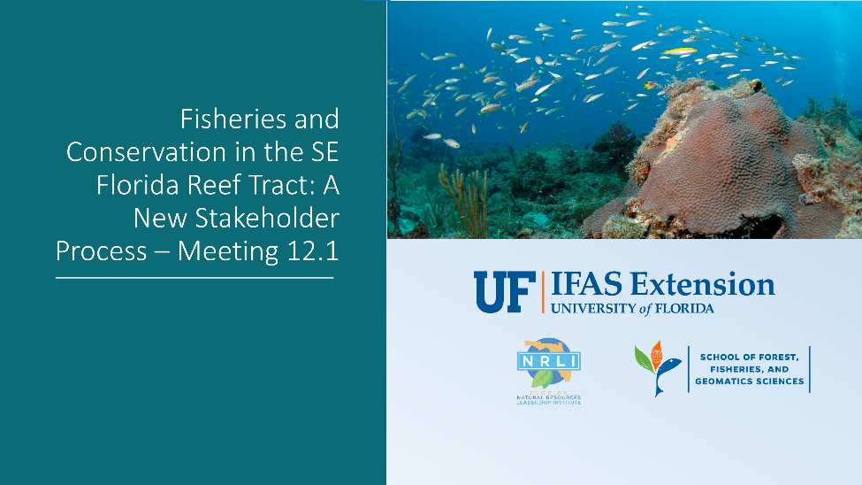
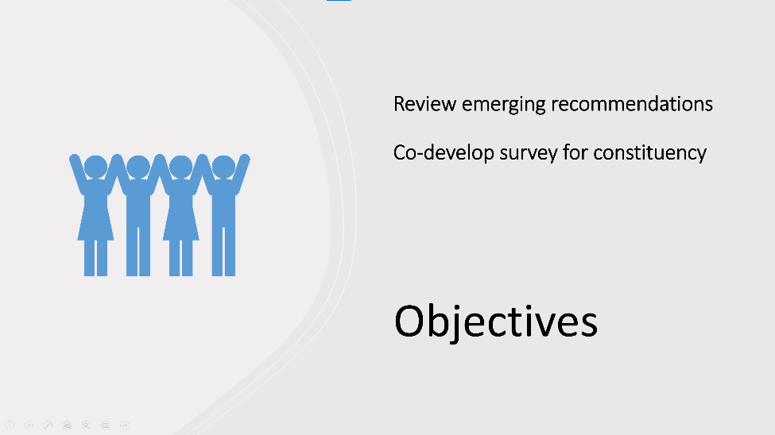
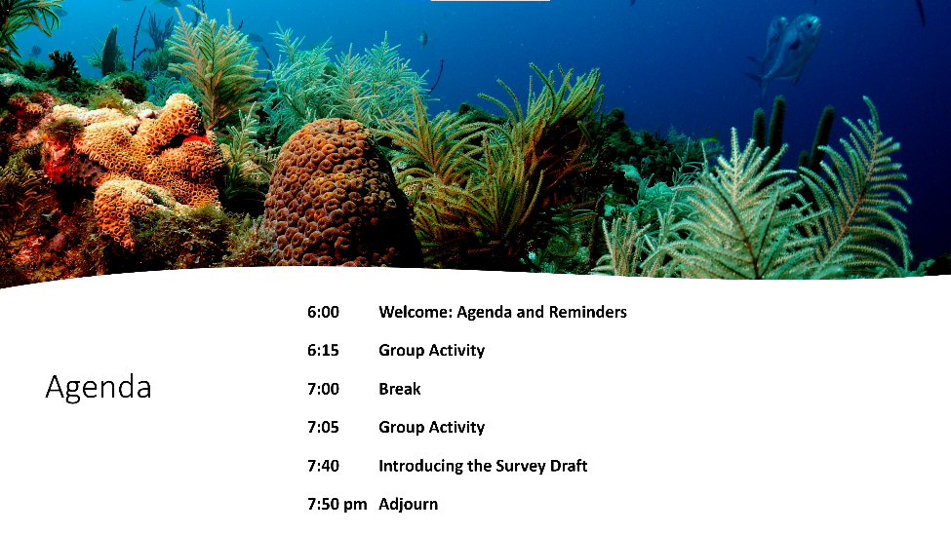

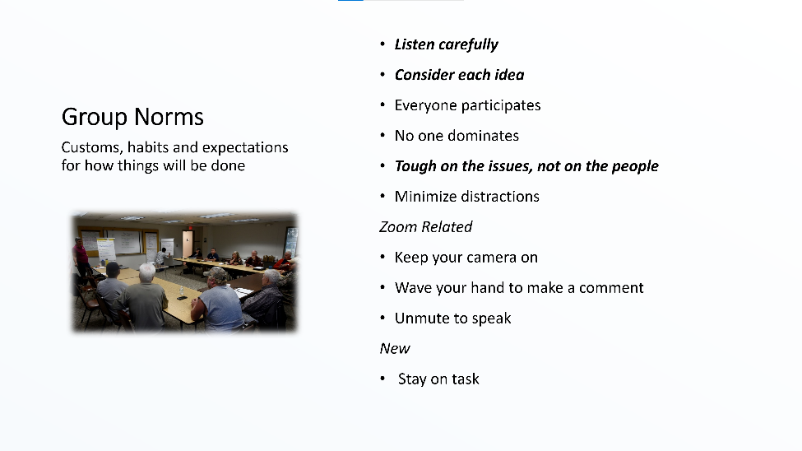
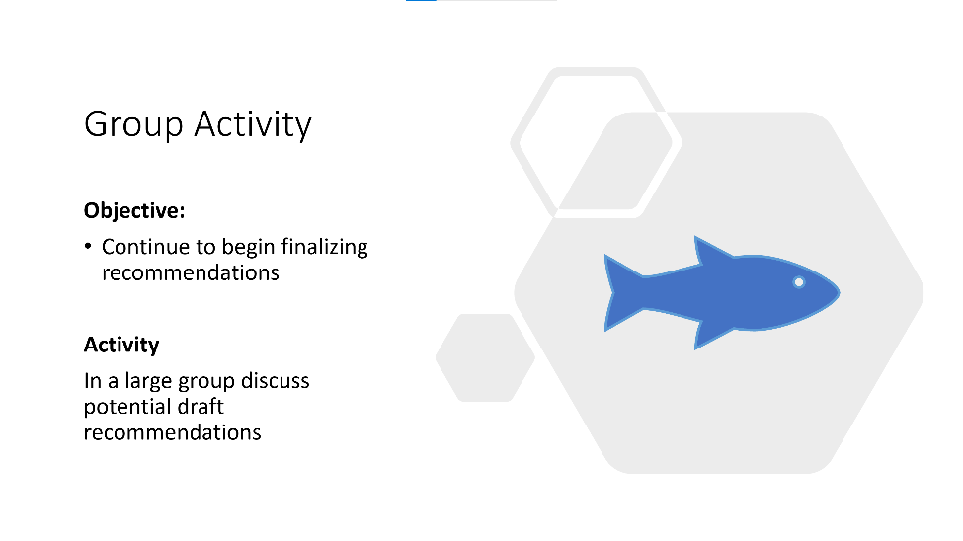
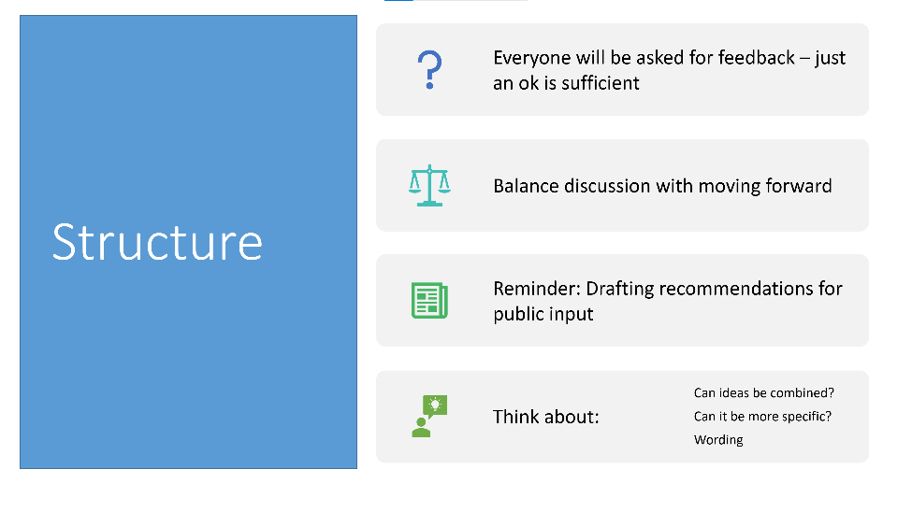
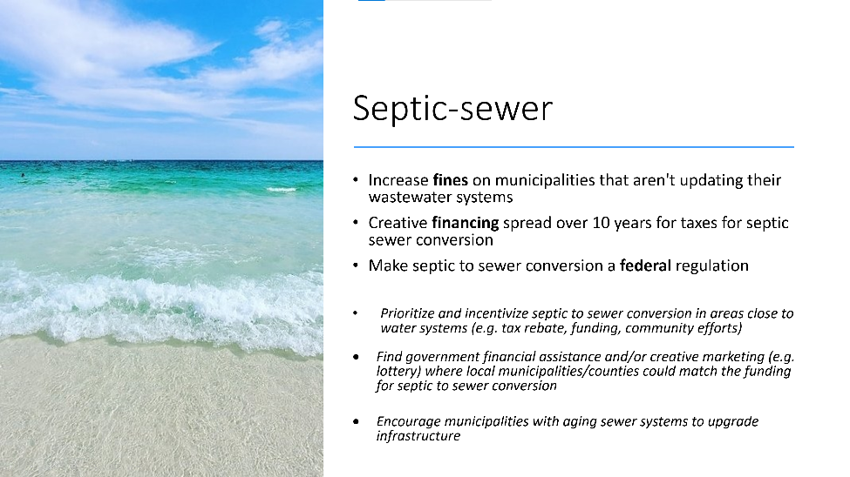
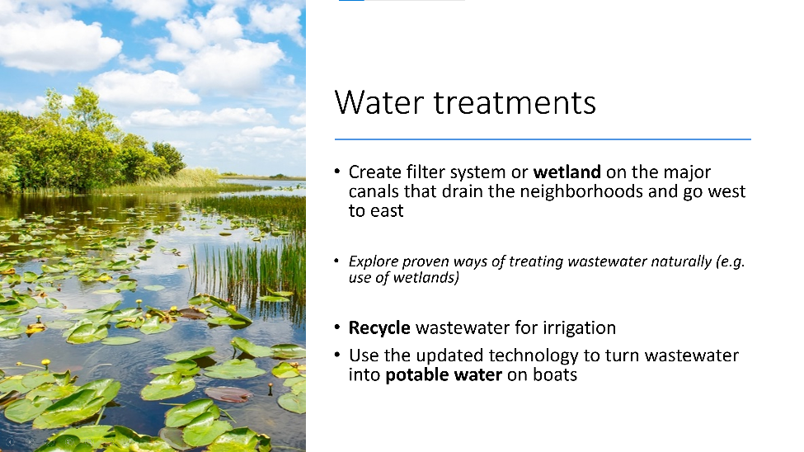
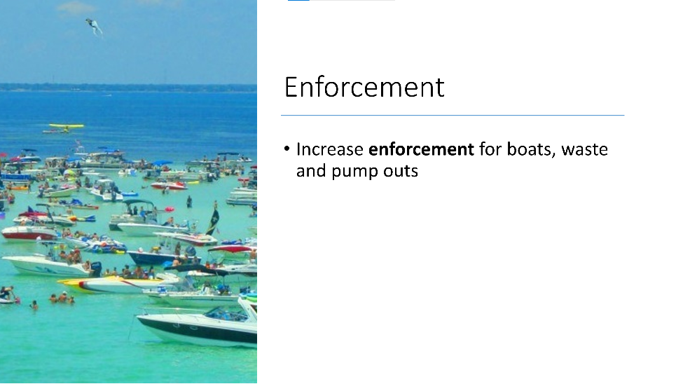
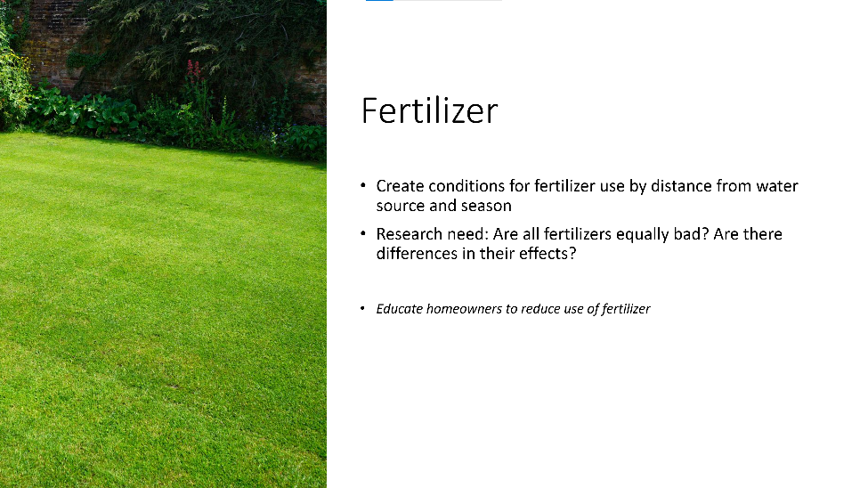
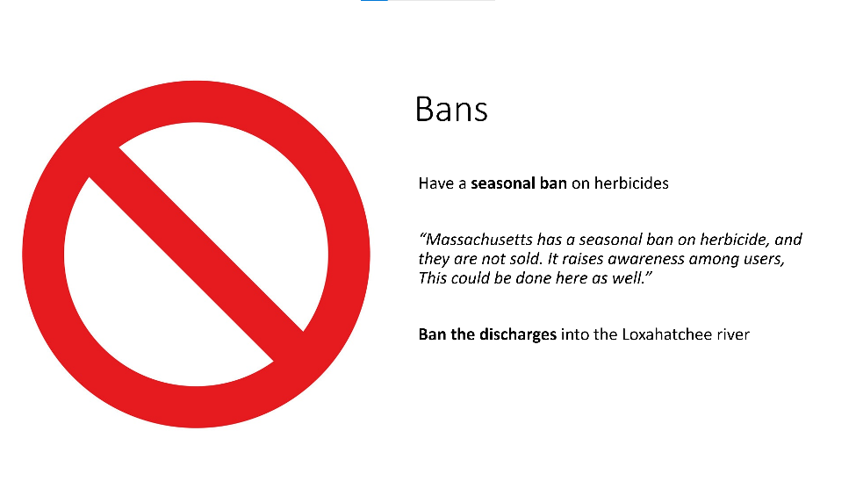
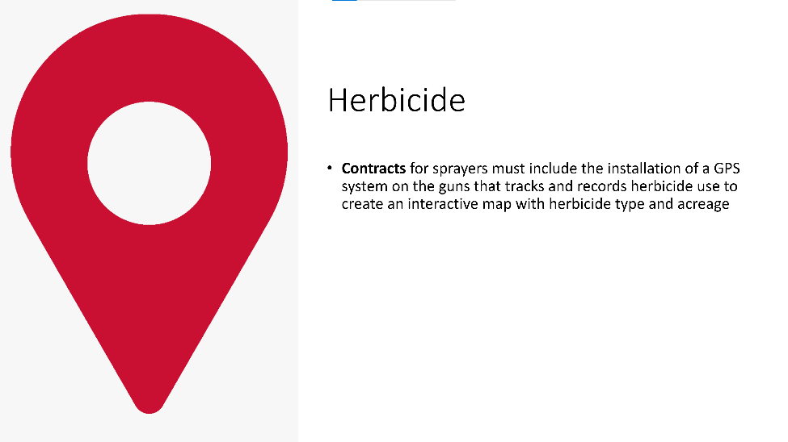

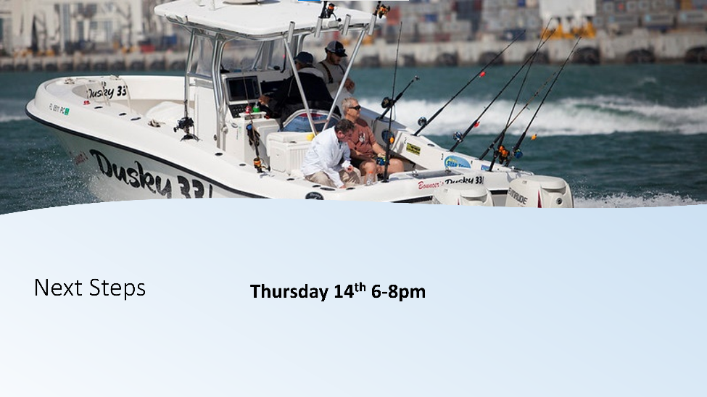

Appendix B

00:28:03 April Price: I agree w/Marty
00:28:19 Kellie Ralston: Passed in 2020 https://www.flsenate.gov/Session/Bill/2020/1091
00:50:15 Joy Hazell (she/her/hers): Encourage municipalities to mitigate pollution from canals - Marty’s recommendation
01:01:50 Captain Dan: Maybe we need a dedicated marine waste police.
01:21:43 April Price: Ft. Pierce - Capt. Mark Dravo on Y-B Normal
01:28:10 April Price: St. Lucie County has a fertilizer ordinance & it's not on the shelf during rainy season
01:29:09 April Price: SLC: June 1st - Sept. 30th
01:32:31 Captain Dan: https://www.local10.com/news/local/2021/04/20/miami-dade-county-approves-tough-new-law-on-fertilizer-marking-a-big-win-for-efforts-to-save-biscayne-bay/
01:43:05 Captain Dan: http://www.leg.state.fl.us/statutes/index.cfm?App_mode=Display_Statute&Search_String=&URL=0500-0599/0576/Sections/0576.181.html

