Coral ECA Fisheries Stakeholder

Committee - Meeting 11 part 2

Virtual meeting via Zoom

6-8 pm, Thursday March 3rd 2022

Summary – March 3rd
Overview
On Thursday, March 3rd the second part of two of the eleventh Fishery Stakeholder Committee meetings was held virtually via Zoom. Project principal investigator Kai Lorenzen and facilitator Susana Hervas attended the meeting.
Eight committee members, seven members of the public, one Florida Fish and Wildlife Conservation Commission staff, and one Florida Department of Environmental Protection employees attended the meeting.
The meeting objectives were to:
- Review emerging recommendations
- Co-develop survey for constituency
Welcome
The start of the meeting was a quick presentation with an explanation and clarification of the meeting agenda and objectives, reminder of group norms – highlighting listen carefully, consider each idea, and tough on the issues, not on the people - and sunshine law (Slides in Appendix 1.). Committee members were also reminded that they will receive the survey by email for feedback. There will be a short presentation today, and a feedback session on Thursday. The zoom chat was available for comments from the team, public and committee (Appendix 2)

Survey Questions and Feedback
The survey draft was introduced on the Tuesday meeting and sent via email to the committee members to review before today's meeting when the team would ask for their feedback:
- When asking for areas where you fish, there should be a free text response
- There will be a map of the ECA
- It’s very lengthy and time consuming
- Almost too general
- Where it says “banning areas” there should be more background, or it could be too vague
- Overall it encompasses what has been discussed and some of the wording could be changed to make it more palatable to the general public to explain it better
- Asking similar things a couple of times is by design
- The survey will be pilot tested
- We want to understand what people support or do not, so if public do not find it palatable, then one can strongly disagree. We want people’s take on a variety of topics.
- Nice to know what the background will say
- Where it says conch, people will take it as queen conch, so best to remove that.
- Seaweed falls more under marine life collector
- “In which regions do you fish most” is it helpful to know if state or federal waters? Will people click on a map?
- ECA needs to be expanded in background
- Offshore or pelagic – inshore can include reef and so can offshore, so classify a little better
- Why is freshwater there?
- Number 4, same as above – offshore and inshore.
- Is it counties or state wide or nation wide?
- For equipment worth, that is a big question – numbers can be all over the place. Is it worth to know cost per trip when they go fishing? Or do you only want long term investment in gear? I think it would be interesting to know how much they spend per trip.
- Ocean water quality – clean and clear. Its difficult to define, because turbid water can still be clean. And clear water can not be clean
- For “reef fish” what definition are we using? – FWC definition which is not well defined? Or snapper and grouper? Or any fish that live in the reef? Because you get snook and sharks out there. So, do we need to limit it to certain species? It-s complicated
- Management ideas: Following options were considered… by whom? In the area, in the reef.. in the ECA?
- Restricting herbicides where? Behind a canal? Or in people’s yards? Same thing with fertilizers. Instead of restrict, would reduce be a better word?
- Clean Lake O. is too ambiguous, maybe reword to “restore the everglades and Lake Okeechobee” – or Everglades restoration including Lake Okechobee
- Fisheries related thing, not sure all the meeting was on board with this.
- If this goes to DEP and they have nothing to do with fisheries management, then curious to know why that is included.
- It is implied that doing any of those things, will improve coral, and that is a big leap.
- Designate some no fishing areas to reduce pressure on reef fish – is a leading question – because it might increase pressure in another area
- Lobster traps – technology was buoys that would come up – was it that? Or maybe having a single buoy per trap instead of a line. What was that technology?
- Doing single trap on single rope
- Habitat protection – designate no fishing areas, again, how does it protect coral? How does that help? We have said it over and over again, but there it is. If you are going to ask that, you will have to do the same thing for diving, boating, anchoring, etc. because not fair to single out a single user group.
- Living shoreline grasses – didn’t understand that – we talked about wording last meeting.
- Warehouse in Orlando with corals – in number 12 and 13 say something about restoring corals and restoring efforts
- A lot of what has been said, has a lot of sense.
- I echo that.
- That was good feedback
- Need to work with how some things are worded, and thinking of federal vs state waters, there is a tradeoff with the detail we can give and being concise enough for people to be clear.
- No indication about committee proposing this. Just feedback.
- Reason why it says reduce fishing pressure and protect habitat, because you could have protected area with different particular reasons. How effective that would be is a different thing.
- Background put together and sent out to the committee.
- If it has an interactive map, it can be cool.
- Number 11 – no need to add that – might be an enforcement question – strengthen enforcement on live aboards regarding dumping.
- Agree with that 100%

Group Activity: Emerging recommendations
The group continued discussions to begin finalizing draft recommendations. In this session they discussed recommendation ideas about i) anchoring, ii) artificial reefs, and iii) information sources. They were reminded to think about combining ideas, wording and being specific.

Anchoring
Create an adopt the reef or adopt the buoys campaign that allows sponsors to advertise on the buoys and show their support for the reef.
Create buoy cluster areas upstream end of reef and more sparse anchoring spots along the reef.
Identify high value sites used by divers and anglers and create a shared buoy system e.g. fishers at night and divers during the day.
- Don’t think you can create a shared system where some go at day vs night
- It should be equal access. Most fishers go during the day.
- Shared buoy system – not see how. If there are divers and fishers.
- There are divers in key Biscayne and every morning there is a dive boat there. There are 7 or 10 buoys. Sometimes I got here, and I tie up there too for fishing. It should be first come first serve
- Neptune reef is there.
- Buoys do not have any restrictions – anyone can go there. People should be able to go dive and fish
- Would be difficult to monitor – if you are fishing and a dive boat comes up.
- But these buoys in Biscayne are separated enough. Designed to not interfere with each other
- A diver was once caught on a trawl.
- Good tool to have in the toolbox – it is a possible resolution but based as a conflict resolution but not a recommendation. Tool for communities or law enforcement to use if ther eis diver fisher conflict but not as a recommendation.
- Guys don’t anchor to dive, they float along. And they come around us because the float dive. Miami Dade might be different but further north they float.
- Keep it as a tool for user conflict
- Buoy clusters at high value sites to avoid people to throwing anchor on the reef.
- If you can create network that prevents anchoring, that is the ultimate goal.
- One challenge with buoys is that you put pressure on that same spot over and over again.
- What we did was to put pins in the bottom and then rotate the buoys so that there was pressure relief.
- There is an adopt the buoys system. And the problem is not that much buying it but maintaining it. Maybe support the creation of maintenance.
- True, people drift dive more. So can only rotate more. Shared buoys system is first come first serve and cannot use as a permanent mooring. And there are rules about it. If there is a diver boat with dive flag up and there are a lot of snorklers in the water, as a fisher you are not allowed to get too close to them and start fishing.
- We could use more buoys in places where feasible. Inshore where current isn’t as strong. PBC has well established mooring buoys program.
- There is a very strong push in our region to create more managed mooring fields. There are tons of boats (sail boats) mooring in lake worth lagoon. Part of proposals from communities is about managed mooring fields. These could have tremendous value! Suggested to have a hundred buoys. So, why not make the anchoring buoys also be artificial reefs? Which might not have high pressure because these buoys are for big boats which might not fish right there. But now all of a sudden we can create 100 artificial reefs. So it could be is a dual role of anchorage and habitat.
- Anchorage issue exists in other areas well, so we could take the opportunity to create mooring fields with artificial reefs in other sites
- Request funding as well
- Also support mooring fields suggested. Last year FWC decided they would allow local governments to put anchoring restrictions – so some areas will have shifting pressure because areas can have more local decision making.
- There has to be a pump out
- Unique group of people (live aboard and from out of state boaters) who spend a lot of money on the state
- Mooring areas are important but is it for transient people or liveaboards who stay there forever? Liveaboard areas can become a mess, boats have sunk and its terrible. Mooring areas are great but have to be monitored. Not all have pump out stations, and they have to be properly managed.
- Not just buoys but managed mooring fields. Maybe charge liveaboards, or have them pay for the artificial reef idea that was mentioned
- Transients will come and go. Fine. But live aboards are a different story
- Discussion is broadening and we are running into complications. Lets focus on mooring on the reef specifically.
- Stick to the reef
- Notes on what exists today with regards to buoys.
  - Miami Dade County 40 buoys
  - Broward 100+
  - PBC 40
  - Martin not installed
  - They all manage own buoys
  - Maintenance cost is $15,000/buoy per year – depends also on the depth (and currents ripping them off)
- Managed mooring fields are in the intercoastal – not on the reef
- We have coral in lake worth lagoon. Lot of animals that move to reef depend on the estuary. So recommendation was – moorings that could be artificial reef to support animals that go out to the reef. It is all connected. And managed mooring fields is a reality, so take the opportunity to create habitat that will also affect the reef ecosystem.
- Same premise as the living sea wall. It’s a good idea
- We could get funding for it.
- Mooring buoys are more for day use. Mooring fields are a different thing, but they are an opportunity.
- Miami Dade is looking at putting a mooring field with 300 buoys.
- So if that will happen, instead of just a cement block, why not make it with holes and relief for habitat
- No objections – and add a sentence, wherever feasible, mooring buoys are not on the reef should also act as a habitat. That is not a problem. Was just concerned about getting too much into the management of every mooring buoy in the state.
- But you have to. It affects the reef eventually – it all matters.
- Fantastic idea to have several purposes for reef – consider where juveniles live as well

Artificial Reefs
Spread numerous and smaller patches of artificial reefs
Artificial reefs made with concrete with holes for water to flow
- Smaller and numerous patches – absolutely
- Assuming stony coral disease continues, and ocean acidification, and coral bleaching continues, would it make sense or not, knowing that the dead exoskeleton will remain dead.. wouldn’t it make sense to make a reef that existed and put something up there so that it can create relief so things could grow there? And to avoid it just turning into sand in 15 years like it happened in Carysfort. Wouldn’t it make sense to say instead of don’t put things on top of natural reefs, to put it on top ofwhere those reefs were?
- I think it should remain illegal. See where you’re coming from – but you are only allowed to pu artificial reef where no current resources are. But if disease slows down, those reef spots are the most likely spots for the coral to begin to regrow. On the rubble that is left. So we are better off creating artificial reefs where there is no natural reef. Darts are good example. We put those where there was no previous resource and now animal communities are growing there.
- We should put artificial reefs and not tell anyone to create refuges. When we put darts, they are not just for fish catching, because it is quite deep as well. But those provide also habitat where it doesn’t exist, on top of recreational opportunities.
- We are making recommendations on things that we are already doing
- Recreate 12, 30, 60 foot reef. Remembering that sand in between reefs are habitat as well. So, lets recreate what we had originally.
- Considering how long it takes and permitting, it could take 15 years. So just looking at being proactive. Will we have stuff alive by then?
- Recommednation should be: Encourage the creation of more artificial reefs made with approved materials like concrete, limestoine rocks, of a complex design that encourages the recruitment of invertebrates and habitat for a wide variety of species. And not pigeon hole ourselves with a specific shape.
- Artificial reefs are already happening on the state. I think recommendation should be to continue to fund and enhance the state artificial reef program. All the other things are already happening and guidelines are strict and in place. But to enhance what is in place.
- State could use more funding to create them. Biggest challenge to ramp up artificial reef program is staging. Notable in southeast Florida. Coast is so developed that there is no place to stage the creation, the building the loading of supplies, the storage of supplies. We have to build darts for PBC in Martin county because there is no place left in PBC to build structures to take offshore.
- Build as many as you can – not sure for how much longer we will have the space.
- Leaving open space near deep water access has been kicked off the market.
- There are ways around that
- We get mitigation with every corps project. Miami is dredging right now. Mitigation is involved with that. And we should have legislation that says you must set apart a spot to for us to put stuff together – since that is part of mitigation to take care of the reefs.
- Full agreement
- And mitigation banks do not have to be seagrass beds. There are other ways to interpret.
- Will it help to put a paragraph together to say that mitigation banks do not have to mean seagrass, it can include upland facilities, downland facilities.. inshore or offshore to help habitat.
- Would be hard for legislators to say no to that.
- We talked about seagrass, how to get it going, and I would go back to the coral and do it for coral
- Lot of ideas coming – these will be put together and sent out to everyone for review.
- Recommend eventually that artificial reef structures of suitable material be considered for placement of these coral fragments that are being grown indoors.
- Still need to know what causes coral disease but that day is coming too.

Information Sources
Science based setting of regulations
Have agencies identify areas that need most protection
Enlist information from citizens to address trends in their observations of key species
- Like having citizens involved like in the survey or meetings. Need to know from citizens. Agencies know very well what is happening. Citizens really would like to be involved in the process, and agencies are not involved. Citizens committee would be responsive and can help us form what we finally put out there
- Science many times is questionable, agencies already know that there are areas that are in bad condition, so what should the committee be saying with respect to those? The last one includes the citizens, and can contribute to buy in
- These are already happening – we are doing fish assessments and they include citizens.
- So, recommendation would be to continue… because if it is already happening, let them know that we want it to keep happening.
- Dredging and coral disease – there is a link between coral disease and port dredging. And they are getting ready to dredge port everglades. Not sure if there is enough science behind that, but it scares me a lot. SO not sure if science based regulations.. I don’t know what the answer is because you need access from and to ports – I get it, but it seems like we are just finishing it off.
- Stony coral disease started in 2014 right in front of where they were dredging at Virginia Key. I was involved in a lawsuit with the Corps of Engineers, and we won in Federal Court. Army Corps never admitted that they were wrong. Everything was rigged and it will still be rigged, and I know – I have been involved in lawsuits since 1989 about dredging in the port. We know what the dredging does. No less traffic of ships come in. Live corals are going to get killed in Broward county. And Army Corps wins every time because they are national security.
- I don’t know what the answer is but it scares me.
- Miami water keepers is suing Everglades dredging and Army Corps, but I gave up.
- Army corps comment period is coming up
- They wouldn’t allow me to talk
- Yes, we should have science based regulations, and say why.
- Say to identify areas that need protection but say from what.
- Get more specific.
- A lot of this is already being done and information is being collected in different ways.
- Recommendation is to do a better job synthesizing the data. There are agencies and research institutions doing work. So if we want trends in fishing, there is no shared database. This applies to fishing and water quality. So recommend to encourage to synthesize information to how we handle these problems
- Synthesis to be a better management tool for decision making because all these things are out there but don’t have a way to look at it in a more concise way.

Wrap up and Adjourn
Appendix 1

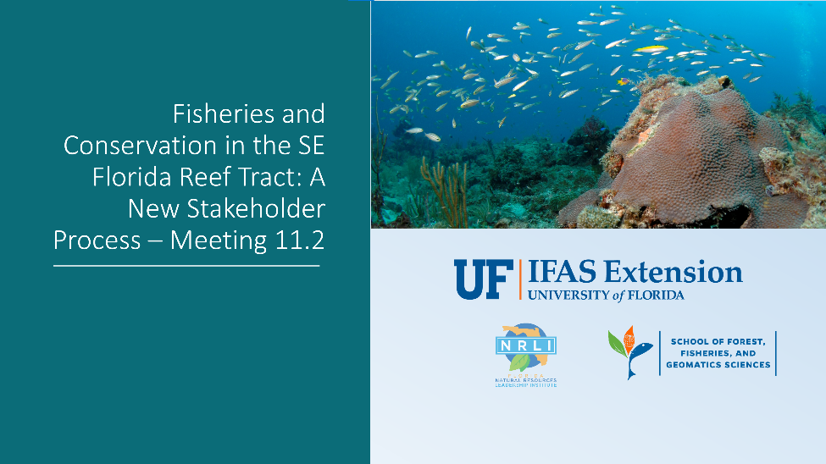
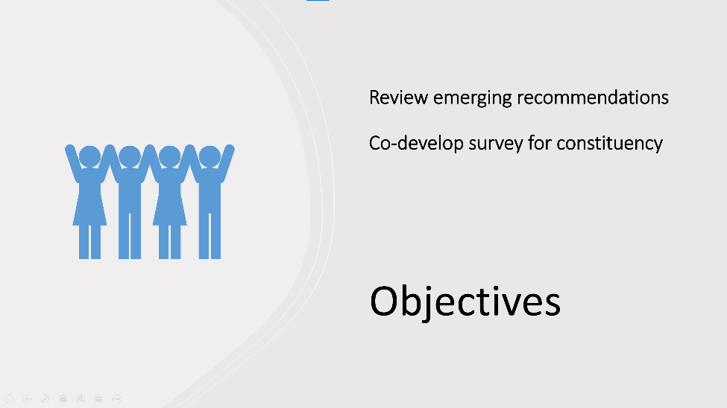
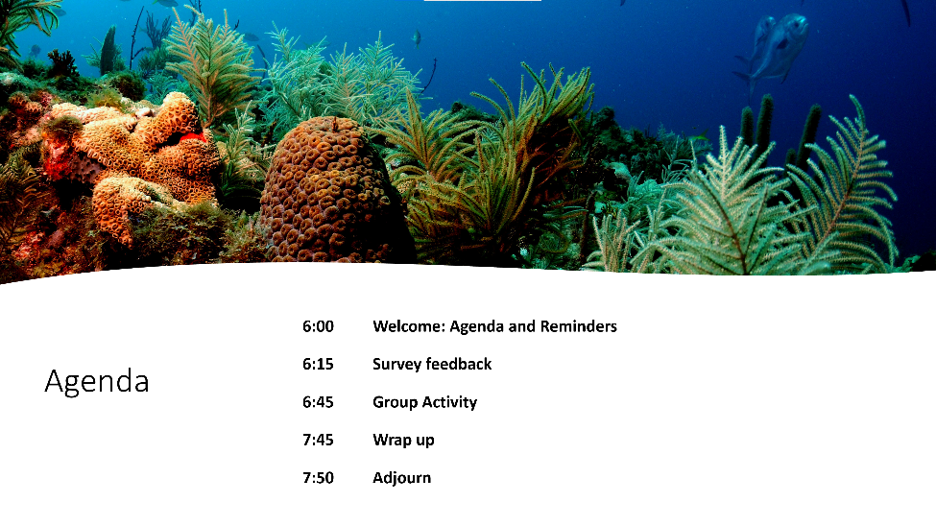

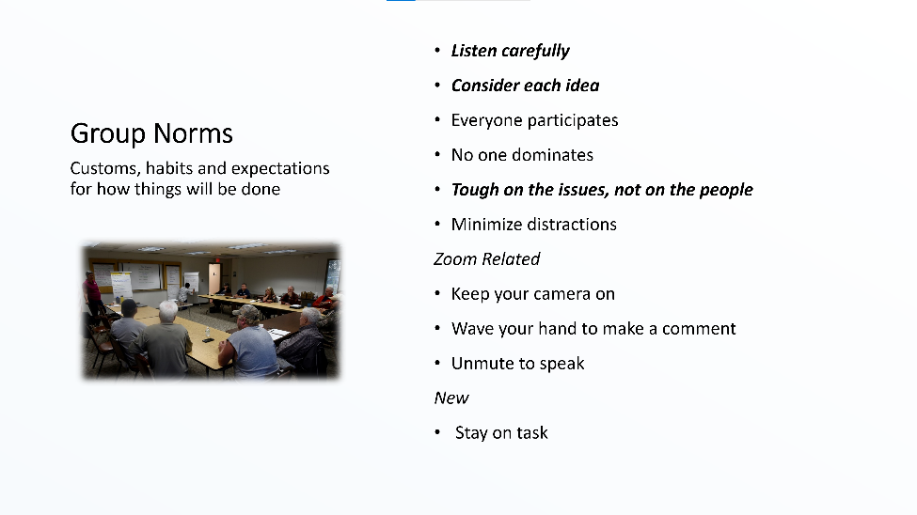
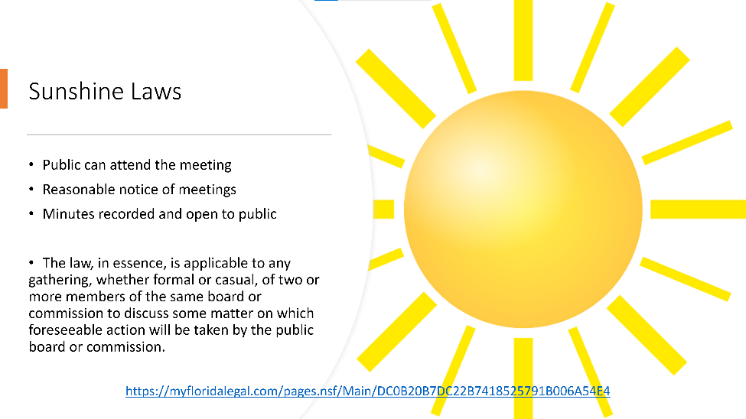
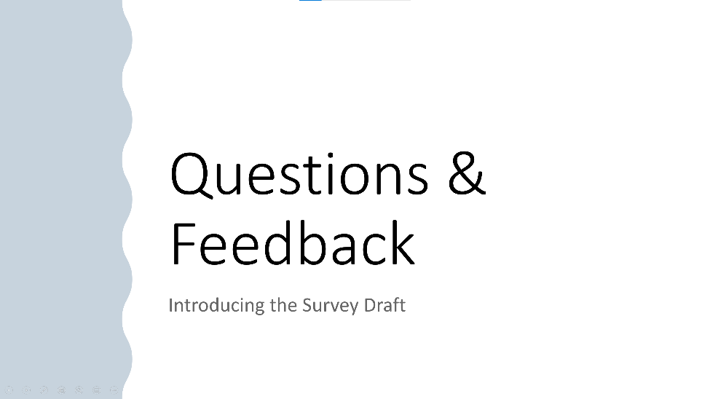

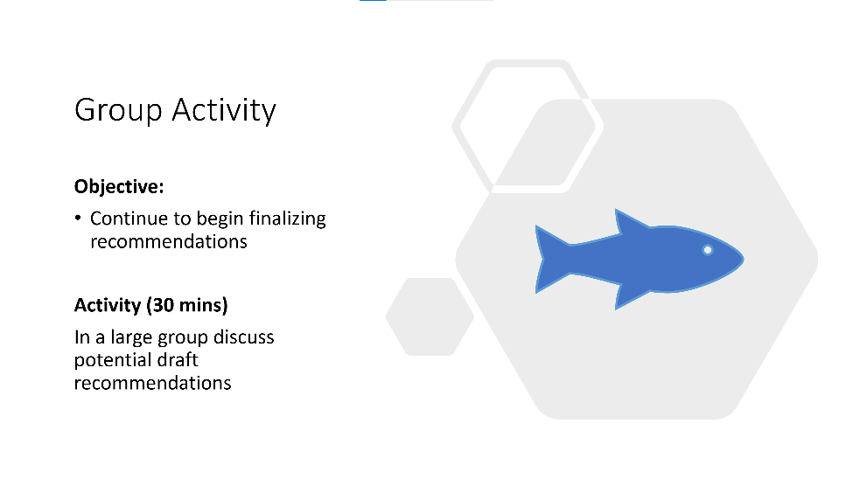
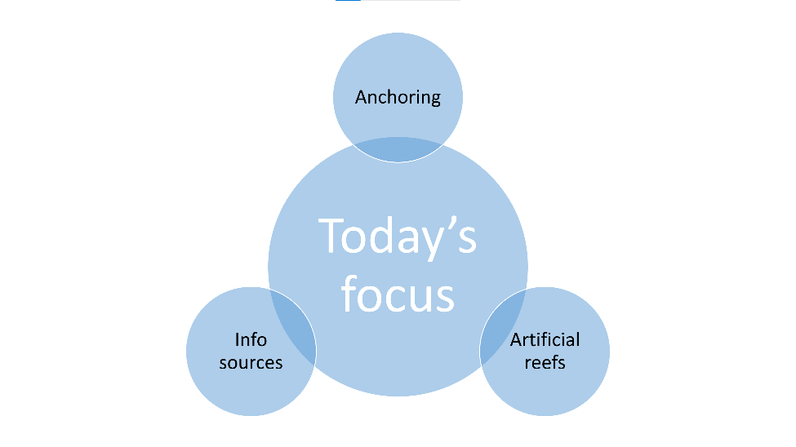

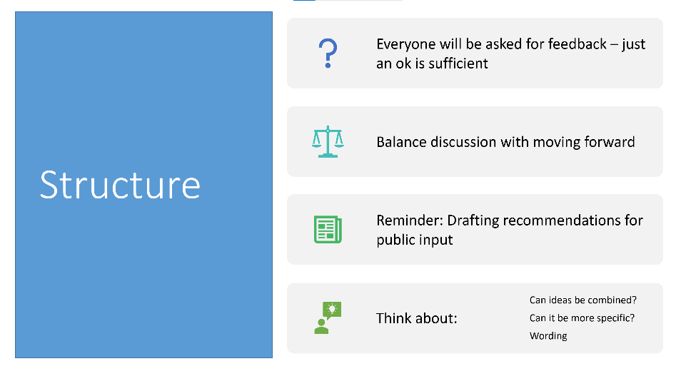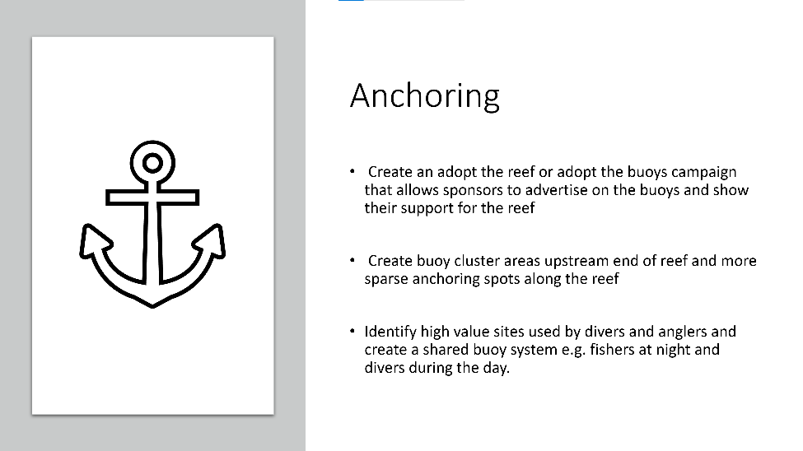
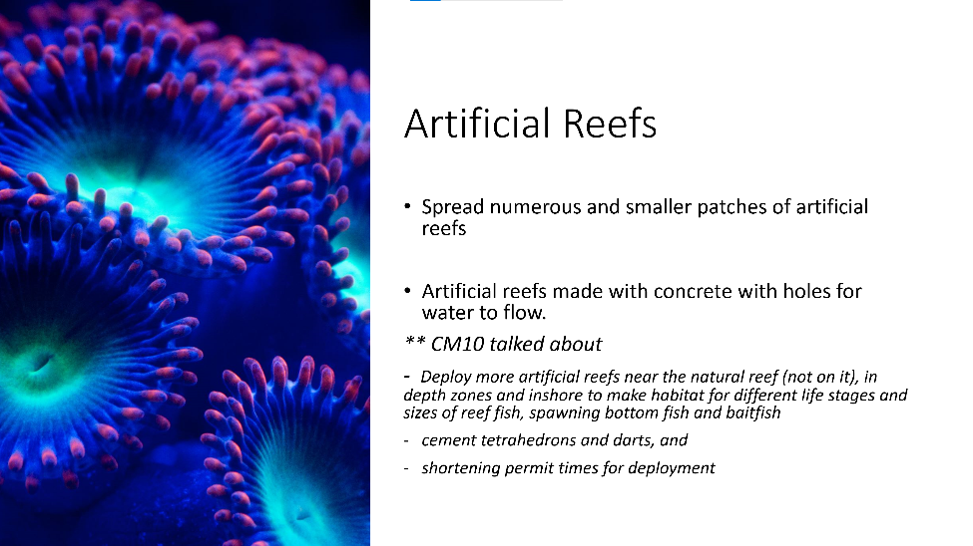
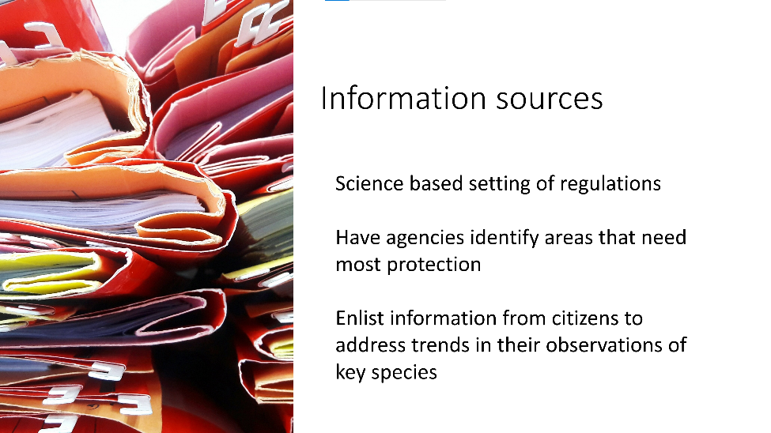

Appendix 2

ZOOM CHAT
00:37:59 April Price: 11. Management ideas / Water Quality - (box 5) "Ban dumping from live aboards" - Activity is already banned`
01:04:21 Katelyn Armstrong - PBC : We have four mooring buoy sites in palm beach county. They’re listed on pbcreefs.com
01:06:34 Katelyn Armstrong - PBC : We have had more in the past, but we lost a ton of them repeatedly and stuck with these four sites, which are spend a good amount $$ to maintain. At each site, we rotate the buoys on a series of anchors/pins to move the pressure.
01:08:29 April Price: I agree, the recommendation should say where feasible & we should recommend funding fpr the projects
01:13:17 Katelyn Armstrong - PBC : Agreed on the funding point (and sorry for the typo above). We were challenged this year by our County Admin and had to defend the 4 sites we currently have in order to keep funding that maintenance.
01:14:33 Jessica Garland: There also used to be mooring buoys in Martin County around the Pecks Lake Reef area but due the cost to replace them repeatedly they are not there any longer.
01:17:43 Jessica Garland: Martin County just opened a Mooring Field in Jensen Beach and is the process of putting another in Manatee Pocket. We also have a pump out boat that services any boat within the county.

https://www.martin.fl.us/JensenBeachMooringField
01:22:21 Katelyn Armstrong - PBC : Yes to the larger boats. That’s a big issue lately up here.
01:22:30 Katelyn Armstrong - PBC : In PBC
01:25:22 April Price: The manage mooring field inshore program belongs under water quality. I too like the living reef concept. Thank you Tom:)
01:56:48 Kellie Ralston: Miami WK won the lawsuit. The USACE has a revised proposal out for comment right now on dredging Pt Everglades...
01:58:13 Mollie Sinnott (FDEP): https://www.saj.usace.army.mil/Media/News-Releases/Article/2924334/jacksonville-district-publishes-revised-draft-supplemental-environmental-impact/
02:03:44 April Price: Thank you Susana!
02:04:12 Katelyn Armstrong - PBC : Thank you

